**Alert Watch and Response Engine (AWARE)**

VistA/CPRS Configuration Guide

Test Account



January 2016

Prepared by Harris Corporation

CLIN 0007AC

Revision History

| Creation Date | Version No. | Description/Comments | Author(s) | Reviewer(s) | Review Type | Issue Date |
| --- | --- | --- | --- | --- | --- | --- |
| 4/24/2015 | .01 | Initial AWARE VistA/CPRS Configuration, and User Setup | G. Welch |  |  |  |
|  |  | Add Configurator/AWARE User Assignments | G. Welch |  |  |  |
| 5/13/2015 | .02 | User Setup assignments changed to site User Account Management.  Instructions added for making Reminder Dialogs “Active”. | G. Welch |  |  |  |
| 1/6/2016 | .03 | Follow format of similar Production Configuration Guide for incorporating Task Assignment and User Task tables | G. Welch |  |  |  |
|  |  |  |  |  |  |  |
|  |  |  |  |  |  |  |
|  |  |  |  |  |  |  |
|  |  |  |  |  |  |  |
|  |  |  |  |  |  |  |

Table of Contents

1 Purpose 4

2 Project Description 6

3 Tasks for Configuration and AWARE User Assignments 6

4.0 AWARE VISTA/CPRS CONFIGURATION 8

4.1 Install AWARE VistA Test Routine Software and Data for Tracked Alert Types into the Test account 8

4.2 Enable the Reminder Dialogs to be used with TIU Templates 9

4.3 Connect Each Reminder Dialog to a created Shared TIU Template 11

4.4 Edit/Verify Fields for Alert Type Initiation 16

4.5 Define Site Lab Text Names for making new Alert Types, and Update the Knowledge Base 18

4.6 Define Site Abnormal Imaging Alert Category(s) and Procedure Names for making new Alert Types, and update the Knowledge Base 23

4.7 Configure the Task Option VEFA AWARE CACHE BUILDER and AWARE CPRS to use the Patient Closeout RPC 25

5.0 AWARE USER SETUP 26

5.1 Enable and Set Up Users with AWARE Linkage 26

5.2 Verify Notification Enabling 31

5.3 Assign Keys, Provider Class, etc. 33

5.4 Assignment of Keys for Using the Alert Cache Viewer/QI Reporting Tool, and Connecting the Alert Cache Viewer to the Tools Menu of AWARE CPRS 34

5.5 Set Up CPRS/AWARE to Use FAT COM Object 36

5.5.1 AWARE CPRS Executable 36

5.5.2 AWARE DLL 43

6.0 AWARE ALERT GENERATION, TESTING, AND PRODUCTION PREPARATION 46

6.1 Generate Generic Alerts for Critical Lab Values and Abnormal Image Results 46

6.2 Exercise the System with Initial Testing 50

6.3 Validation with Re-Factoring Preparation of Reminder Dialogs Data 57

7.0 APPENDICIES 58

7.1 Appendix A – Example of Reminder Dialog Exchange to Load & Install Reminder Dialogs 58

7.2 Appendix B – Example Determination of Imaging Alert Category and Alert Types for Lung Cancer Detection 83

7.3 Appendix C – Example KB Editing Steps from determined Imaging Alert Category and Alert Types for Lung Cancer Detection 86

7.4 Appendix D – Alternate Method for Generating Artificial Lab Alerts 88

7.5 Appendix E – Examples of Site Customization with Reminder Dialogs 96

List of Figures

Figure 1 - VistA CPRS 3

Figure 2 - Create New Shared Template 3

Figure 3 - Template Editor 3

Figure 4 - Choose "Reminder Dialog" 3

Figure 5 - Reminder Dialog 3

Figure 6 – CPRS 3

Figure 7 – Run the Aware CPRS Desktop Installer 3

Figure 8 – Accept the Aware License Agreement 3

Figure 9 – Enter the sites VistA Server Address and Port Number 3

Figure 10 – Complete the Installation 3

Figure 11 - VistA AWARE KB Editor, Alert Type 3

Figure 12 – VEFAALRE Context Option Assignment Error 3

Figure 13 – Cannot Use Reminder Dialog 3

Figure 14 - Options, Notifications 3

Figure 15 - Options, Notifications (Continued) 3

Figure 16 - Add a New Alert Category 3

Figure 17 - Add a New Alert Category (Continued) 3

Figure 18 - Associated Alert 3

Figure 19 - VistA Sign 3

Figure 20 - Patient Selection 3

Figure 21 - VistA CPRS In Use 3

Figure 22 - Follow-Up Action Tracker 3

Figure 23 - Location for Current Activities 3

Figure 24 - Location for Current Activities 3

Figure 25 - Location for Current Activities (Continued) 3

Figure 26 - Progress Note Properties 3

Figure 27 - Reminder Dialog 3

Figure 28 - Selecting Location for Current Activities 3

Figure 29 - Order a Lab Test 3

Figure 30 - Click the Quit Button 3

Figure 31 - Review/Sign Changes 3

Figure 32 - Lab Test Number 3

Figure 33 - AWARE Prompt 3

# Purpose

The purpose of this document is to provide a guidebook of instructions on how to do an initial VistA configuration and user setup of Core AWARE functionality in VistA into a Test account. Core AWARE is the source for tracking of follow-up action within the CPRS and VistA environments. It starts following a prior AWARE software KIDS build and the loading of AWARE data for four AWARE Alert types including associated Reminder Dialogs. First, additional KIDS file installations are made containing specific AWARE Test routines and Test data. Instructions follow for performing AWARE VistA configuration and specific configuration for use with AWARE CPRS. Then instructions are included for user setup, and validation for Core AWARE functionality. References are also made and relationships are defined to additional enhanced AWARE components and functionality beyond the Core AWARE components; however the details of these enhanced AWARE components are covered in other documents. These components include the Knowledge Base (KB) Editor, the Alert Cache Viewer, and the Quality Improvement (QI) Reporting Tool. An initial testing of this Core AWARE functionality is concluded with a preparation of site customized AWARE data made in the Test account whose data can be used in a subsequent Core AWARE installation in a Production account. Specific sections of this guide can be performed as designated and led by Clinical Application Coordinator (CAC) and supported by Information Resource Management (IRM) staff.

Following a prior KIDs files and Reminder Dialog installation and download , the document proceeds thru a comprehensive set of steps for completing the general Core AWARE VistA configuration, and then through the steps for specific AWARE user setup.

The purpose of this document includes the following:

1. To provide configuration/setup of Core AWARE functionality including site specific configuration, and user AWARE setup with a quick follow-up testing of functionality. This is an independent path not dependent on AWARE enhancement installation/setups or other installation bottlenecks, but serves to quickly attain Core AWARE functionality and verification of such which is essential for the proper functioning of all AWARE enhancement components based on this Core AWARE component.
2. To introduce AWARE enhancement features with appropriate language and brevity at appropriate entry points of proper use within the setup steps, and with references to other documents for actually doing this detail work at a later time.
3. To provide a “Guidebook” of comprehensive instructions in the correct order of implementation to allow a “coordinator” or small group of coordinators to get started correctly in implementing AWARE, and as a guidebook providing a future unified reference of integrated features for understanding all of the various AWARE components as a whole.

The last configuration ends with the Alert Cache Builder task setup. The user setup ends with a connection of the “Alert Cache Viewer” web program from CPRS retrieving the Alert Cache data generated from this task.

Finally, a quick testing of Core AWARE functionality follows.

# Project Description

The Computerized Patient Record System (CPRS) View Alerts package delivers notification of non-life threatening critical test results; however, it does not track whether providers take appropriate follow-up actions in response to the alerts. Currently, the only way to track follow-up actions on critical alerts is through manual review of individual patient records. The innovation Alerts, Watch and Response Engine (AWARE) will track and monitor follow-up actions and will identify certain critical lab and imaging test result alerts that lack timely follow-up. AWARE also consists of a web-based Knowledge Base (KB) editor, an Alert Cache Viewer, and QI Reporting Tool.

This document refers to the Core AWARE Test Routine and Data installation, configuration, and user setup in VistA and the use of an AWARE customized CPRS and additional COM object to allow enabling of Core AWARE functionality. An introduction and reference to the enhanced capabilities are made to the web-based Knowledge Base (KB) Editor, the Alert Cache Viewer, and the QI Reporting Tool.

# Tasks for Configuration and AWARE User Assignments

|  |  |  |
| --- | --- | --- |
| **Assign To** | **Task** | **Instruction in Section** |
|  | AWARE VISTA/CPRS CONFIGURATION | 4.0 |
| OI&T Specialist | Install AWARE VistA Test Routine Software and Data for Four Tracked Alert Types into the Test Account | 4.1 |
| Clinical Application Coordinator (CAC) | Enable the Reminder Dialogs to be used with TIU Templates | 4.2 |
| Clinical Application Coordinator (CAC) | Connect Each Reminder Dialog to a created TIU Template | 4.3 |
| Clinical Application Coordinator (CAC) | Edit/Verify Fields for AWARE Template Alert Types | 4.4 |
| Clinical Application Coordinator (CAC) | Define Site Lab Test Names for making new Alert Types, and update the Knowledge Base | 4.5 |
| Clinical Champion (M.D medical doctor)/Laboratory Lab Chief |  | 4.5 a |
| Clinical Application Coordinator (CAC) and/or OI&T specialist |  | 4.5 b |
| OI&T specialist |  | 4.5 c |
|  | Define Site Abnormal Imaging Alert Category(s) and Procedure Names for making new Alert Types, and update the Knowledge Base | 4.6 |
| Clinical Informatics person (or a Champion M.D. medical doctor), and/or a Radiology Department Chief |  | 4.6 a |
| Clinical Application Coordinator (CAC) |  | 4.6 b |
| OI&T Specialist | Configure the Option VEFA AWARE CACHE BUILDER and Allow AWARE CPRS to use the Patient Closeout RPC | 4.7 |
|  | **AWARE USER SETUP** | 5.0 |
| Clinical Application Coordinator (CAC)/OI&T Specialist | Enable and Set Up Users with AWARE Linkage | 5.1 |
| Clinical Application Coordinator (CAC)/OI&T Specialist | Verify Notification Enabling | 5.2 |
| Clinical Application Coordinator (CAC)/OI&T Specialist | Assignment of Keys, Provider Class, etc. | 5.3 |
| Clinical Application Coordinator (CAC)/OI&T Specialist | Assignment of Keys for using the Alert Cache Viewer, and connecting the Alert Cache Viewer to the Tools Menu | 5.4 |
| Clinical Application Coordinator (CAC)/OI&T Specialist | Setup CPRS/AWARE to use COM Object | 5.5 |
|  | **ALERT GENERATION, TESTING, AND PRODUCTION PREPARATION** | 6.0 |
| Testing staff (Initial Users as Clinical Application Coordinators (CACs), Clinical Informatics personnel (i.e., a Champion M.D. medical doctor), or OI&T Specialists) | Generate Alerts for Critical Lab Values and Abnormal Imaging Results | 6.1 |
| Initial Users (Clinical Application Coordinators (CACs), Clinical  Informatics personnel (i.e., a Champion M.D. medical doctor), or OI&T Specialists) | Exercise the System with Initial Testing | 6.2 |
| Clinical Application Coordinators (CACs), Clinical Informatics personnel (i.e., a Champion M.D. medical doctor) | Validation with Re-Factoring Preparation of Reminder Dialogs Data | 6.3 |

User Assignments Table:

|  |  |  |  |  |
| --- | --- | --- | --- | --- |
| **User** |  |  | **Assignment Type (option, key, parameter, AWARE CPRS on workstation) within 4.0 AWARE VistA/CPRS CONFIGURATION and 5.0 AWARE USER SETUP** | **Section for which assignment is needed or done within 4.0 and 5.0, respectively** |
| **Local IRM (OI&T Specialists)** |  |  |  |  |
|  | Secondary Option: |  | PXRM MANAGERS MENU  (for loading reminder dialogs) | 4.1, Appendix A |
|  | Key: |  | VEFA AWARE ADD/EDIT KB RULE | 4.4 |
|  |  |  | VEFA AWARE ALL ALERT CACHE | 5.4 a |
|  | Parameter: |  | VEFA ORWCOM PAT CHART CLOSEOUT | 5.1 a |
| **Clinical Application Coordinator (CAC)** |  |  |  |  |
|  | Secondary Option: |  | VEFAALRE | 5.1 b |
|  |  |  | ORW TOOL MENU ITEMS  (For adding Alert Cache Viewer to CPRS Tools Menu by individual user , or by system to include all CPRS users) | 5.4 b |
|  | Key: |  | VEFA AWARE ADD/EDIT KB RULE | 4.4, 4.6 b, 4.7 b, 4.10 |
|  |  |  | VEFA AWARE ALL ALERT CACHE | 5.4 a |
|  | Parameter: |  | VEFA ORWCOM PAT CHART CLOSEOUT | 5.1 a |
|  |  |  | TIU TEMPLATE REMINDER DIALOGS (up to 4 parameterizations by user unless done by system for all users). | 4.2 |
|  | Other: |  | AWARE CPRS on Workstation | 5.5 |
| **Clinical Champion (M.D.)** |  |  |  |  |
|  | Secondary Option: |  | ORCM MGMT  (for refactoring reminder dialogs) | 4.5, 4.9, Appendix B |
| **Clinician** |  |  |  |  |
|  | Secondary Option: |  | VEFAALRE | 5.1 b |
|  | Key: |  | VEFA AWARE ALL ALERT CACHE | 5.4 a |
|  |  |  | or |  |
|  |  |  | VEFA AWARE OWN ALERT CACHE | 5.4 a |
|  | Parameter: |  | VEFA ORWCOM PAT CHART CLOSEOUT | 5.1 a |
|  |  |  | TIU TEMPLATE REMINDER DIALOGS (up to 4 parameterizations by user unless done by system for all users). | 5.1 c |
|  | Other: |  | AWARE CPRS on Workstation | 5.5 |
| **Nurse** |  |  |  |  |
|  | Secondary Option: |  | VEFAALRE | 5.1 b |
|  | Parameter: |  | VEFA ORWCOM PAT CHART CLOSEOUT | 5.1 a |
|  |  |  | TIU TEMPLATE REMINDER DIALOGS (up to 4 parameterizations by user unless done by system for all users). | 5.1 c |
|  | Other: |  | AWARE CPRS on Workstation | 5.5 |
| **Patient Safety Managers, Quality Personnel, Nursing Managers** |  |  |  |  |
|  | Secondary Option: |  | VEFAALRE | 5.1 b |
|  | Key: |  | VEFA AWARE ALL ALERT CACHE | 5.4 a |
|  | Parameter: |  | VEFA ORWCOM PAT CHART CLOSEOUT | 5.1 a |
|  | Other: |  | AWARE CPRS on Workstation | 5.5 |

**NOTE:** The following two security keys included in the User Assignment table above control the Users access to viewing AWARE Alerts.  One permits a User to see All Alerts, the other only their Alerts.

When testing and using this application it is important to understand this difference between these two Security key permissions.   Depending on the role of the Physician/clinician the site may want a Senior Physician/clinician such as the COS to have the View ALL ALERTS key.

VEFA AWARE ALL ALERT CACHE:

This permits the user to be able to view all alerts.

VEFA AWARE OWN ALERT CACHE:

This restricts the users View so they can only see their own alerts.

# 4.0 AWARE VISTA/CPRS CONFIGURATION

# 4.1 Install AWARE VistA Test Routine Software and Data for Tracked Alert Types into the Test account

The complete AWARE VistA software including test routines and data for four Tracked Alert Types , and four template reminder dialog exchange files are contained in zip files that can be downloaded from the AWARE site ([https://54.225.241.69/svn/aware/Deployment/AWARE Version 1.1.x/](https://54.225.241.69/svn/aware/Deployment/AWARE%20Version%201.1.x/) or at [https://github.com/VHAINNOVATIONS/AWARE/trunk/Deployment/AWARE Version 1.1.x/](https://github.com/VHAINNOVATIONS/AWARE/trunk/Deployment/AWARE%20Version%201.1.x/) for OSEHRA) for version x. The AWARE KIDS software and Reminder Dialog data are in a **KIDS_REMINDER_DIALOGS_v_1_x__zzz_VMS.zip**, or **KIDS_REMINDER_DIALOGS_v_1_x_zzz.zip** file as used with either OpenVMS or Linux, respectively. Here “zzz” stands for the “CHA” for Charleston version, or “LON” for Long Beach version. A KIDs build for test routines and test data are in a **VEFA_TESTDATA_1_0_VMS.zip or VEFA_TESTDATA_1_0.zip** file as used with either OpenVMS or Linux, respectively. The AWARE download sites use Subversion to store the software. Use your allowed username and password to download the software.

Extract the contents of the appropriate test routines and test data from the **VEFA_TESTDATA_1_0_*.**zip file.

The following KIDS build installation for test routines and test data below should follow a previous installation of the AWARE software **VEFA_2_0_2zzz.KID** and **VEFA_1_0_3_KB.KID** files made from the T4_AWARE_InstallGde-KIDS_CSP document.

**An OI&T specialist is then recommended to do the step below:**

1. Load the Test routines and options and template data as below for making Alerts to exercise the system in the Test account.
   1. Load and Install the KIDS file **VEFA_TESTDATA_1_0.KID** for adding testing tools and test data. This multi-build includes an environment check routine: VEFACHKE to allow installation only into a Test account.

From a Test account location that Reminder Exchange files have been previously downloaded by OI&T specialist, **an OI&T specialist can then Load and Install the following Reminder Exchange files below**:

* AVEFAC_PSA.PRD
* AVEFAC_FOBT-FIT.PRD
* AVEFAC_ABNORMAL_CXR.PRD
* AVEFAC_ABNORMAL_MAMMOGRAM.PRD

See Appendix A – Example of Reminder Dialog Exchange to Load and Install Reminder Dialogs for instructions on loading and installing Reminder Dialogs as a guide for doing this work.

Also, change the status of these Reminder Dialogs from a “Disabled” to “Active” status. The instructions for such are included in this same Appendix.

The subsequent remaining steps for AWARE VistA configuration and user setup should be managed with responsibilities through an **AWARE Coordinator** and then through **Clinical Application Coordinator(s**) with duties assigned among their staff plus any other **OI&T staff** as specifically deemed necessary at their site. A first pass for the user setup steps can initially be exercised to allow a clinical coordinator to act as a pseudo physician provider to use and demonstrate the AWARE functionality. A subsequent pass through the user setup steps of this Guide can be performed for setting up additional AWARE users.

# 4.2 Enable the Reminder Dialogs to be used with TIU Templates

**We recommend that a Clinical Application Coordinator (CAC) complete this step. It can also be accomplished by an OI&T Specialist/Programmer.**

Enable each of the four AWARE template Reminder Dialogs to be used with a TIU template.. The example below shows a PSA reminder dialog named AVEFA PSA:

This step can be done by or on behalf of each Clinical Application Coordinator.

1. Logon as a Clinical Coordinator.

Volume set: ROU:CACHEINV UCI: CPM Device: /dev/pts/0 (173.252.156.129)

ACCESS CODE:

ACCESS CODE: *******

VERIFY CODE: ********

Good afternoon BUDDIE

You last signed on today at 13:43

PCE Basic PCE Hands-On ...

AICS Encounter Forms ...

OE CPRS Manager Menu ...

PX Reminder Managers Menu ...

XX General Parameter Tools ...

1. Select Training Menu <TEST ACCOUNT> Option**: xx General Parameter Tools**

LV List Values for a Selected Parameter

LE List Values for a Selected Entity

LP List Values for a Selected Package

LT List Values for a Selected Template

EP Edit Parameter Values

ET Edit Parameter Values with Template

EK Edit Parameter Definition Keyword

You Select General Parameter Tools <TEST ACCOUNT> Option: **ep Edit Parameter Values**

--- Edit Parameter Values ---

1. Select PARAMETER DEFINITION NAME: **TIU TEMPLATE REMINDER DIALOGS** Reminder Dialogs allowed as Templates

TIU TEMPLATE REMINDER DIALOGS may be set for the following:

**1 User USR [choose from NEW PERSON]**

3 Service SRV [choose from SERVICE/SECTION]

4 Division DIV [choose from INSTITUTION]

5 System SYS [GOLD.VAINNOVATION.US]

1. Enter selection: 1 User NEW PERSON
2. Select NEW PERSON NAME: CLINCOORDINATOR,ONE 🡨----- FIRST CHOOSE CLINICAL COORDINATOR(S) with example name shown here to able to do additional setup steps as well

CLINCOORDINATOR,ONE

Setting TIU TEMPLATE REMINDER DIALOGS for User CLINCOORDINATOR,ONE

1. Select Display Sequence: 1

Are you adding 1 as a new Display Sequence? Yes// **YES**

Display Sequence: **1// 1**

Clinical Reminder Dialog: **AVEFA**

🡨 enter only “AVEFA” to list all 4 of the AWARE Reminder Dialogs.

1 AVEFA ABNORMAL CXR reminder dialog LOCAL

2 AVEFA ABNORMAL MAMMOGRAM reminder dialog LOCAL

3 AVEFA FOBT-FIT reminder dialog LOCAL

4 AVEFA PSA reminder dialog LOCAL

CHOOSE 1-4: 1 **AVEFA ABNORMAL CXR reminder dialog LOCAL**

Select Display Sequence: **2**

Are you adding 2 as a new Display Sequence? **Yes// YES**

Display Sequence: **2// 2**

Clinical Reminder Dialog: **AVEFA ABNORMAL MAMMOGRAM reminder dialog LOCAL**

...OK? **Yes// (Yes)**

Select Display Sequence: **3**

Are you adding 3 as a new Display Sequence? **Yes// YES**

Display Sequence: **3// 3**

Clinical Reminder Dialog: **AVEFA FOBT-FIT reminder dialog LOCAL**

...OK? **Yes// (Yes)**

Select Display Sequence: **4**

Are you adding 4 as a new Display Sequence? **Yes// YES**

Display Sequence: 4// **4**

Clinical Reminder Dialog: **AVEFA PSA reminder dialog LOCAL**

...OK? **Yes// (Yes)**

Select Display Sequence:

TIU TEMPLATE REMINDER DIALOGS may be set for the following:

1 User USR [choose from NEW PERSON]

3 Service SRV [choose from SERVICE/SECTION]

4 Division DIV [choose from INSTITUTION]

5 System SYS [MAE-TEST]

**NOTE:** All 4 reminder dialogs (AVEFA FOBT-FIT, AVEFA ABNORMAL CXR, and AVEFA ABNORMAL MAMMOGRAM) are added by increasing the Display Sequence: by 1 each time.

Also, this parameterization can be done once for each Reminder Dialog by “System” if desired instead of by “user”.

# 4.3 Connect Each Reminder Dialog to a created Shared TIU Template

Connect each Reminder Dialog to a created Shared TIU template in CPRS.

**NOTE: We recommend that a Clinical Application Coordinator (CAC) complete this step. It can also be accomplished by an OI&T Specialist/Programmer.**

**Make sure this step is done one and only one time for each Reminder Dialog by a Clinical Application Coordinator or an OI&T Specialist/Programmer.**

Create a new Shared TIU template and link the Reminder Dialog template to it in CPRS. A Clinical Coordinator needs to do this. Assign use as a Shared Template in the steps as shown below:

Select Training Menu <TEST ACCOUNT> Option: **xx General Parameter Tools**

LV List Values for a Selected Parameter

LE List Values for a Selected Entity

LP List Values for a Selected Package

LT List Values for a Selected Template

**EP Edit Parameter Values**

ET Edit Parameter Values with Template

EK Edit Parameter Definition Keyword

You Select General Parameter Tools <TEST ACCOUNT> Option: **ep Edit Parameter Values**

--- Edit Parameter Values ---

Select PARAMETER DEFINITION NAME: PXRM GUI REMINDERS ACTIVE

PXRM GUI REMINDERS ACTIVE may be set for the following (First be sure the parameter for Division or System is set “Active”):

1 User USR [choose from NEW PERSON]

2 Service SRV [choose from SERVICE/SECTION]

3 Division DIV [choose from INSTITUTION]

4 System SYS [GOLD.VAINNOVATION.US]

Enter selection: 4 System GOLD.VAINNOVATION.US

Setting PXRM GUI REMINDERS ACTIVE for System: GOLD.VAINNOVATION.US

REMINDERS ACTIVE: YES// ^

Next, do the following with these associations for all 4 Reminder dialogs as below:

Reminder Dialog TIU template

(names below) (names below)

**AVEFA FOBT-FIT AWARE ABNORMAL FOBT-FIT**

**AVEFA PSA AWARE ABNORMAL PSA**

**AVEFA ABNORMAL CXR AWARE ABNORMAL CXR**

**AVEFA ABNORMAL MAMMOGRAM AWARE ABNORMAL MAMMOGRAM**

1. Login to CPRS (*CPRS version without AWARE customization) as a Clinical Coordinator
2. Go to Notes Tab in CPRS

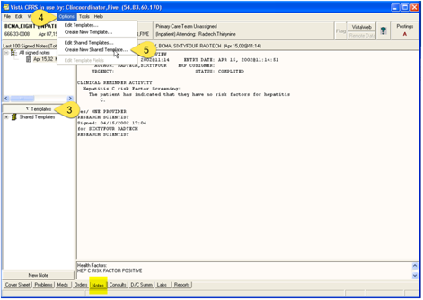

Figure - VistA CPRS

1. Click on Templates Drawer
2. Click on “Options” Menu
3. Click on “Create New Shared Templates”

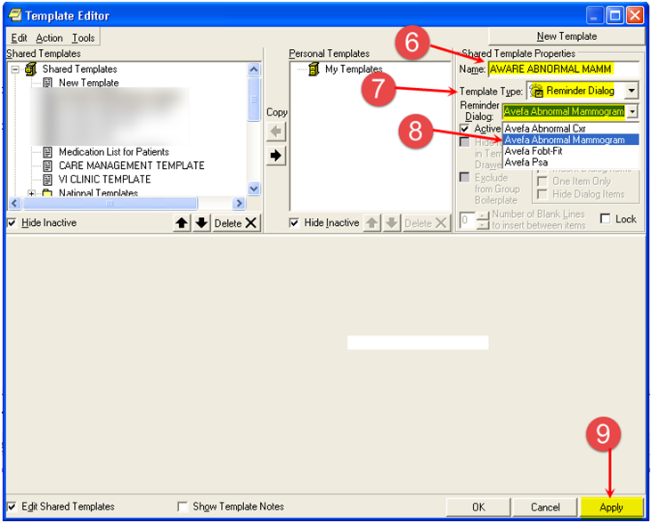

Figure - Create New Shared Template

1. Rename New Template to new alert TIU template as above, in this case, “AWARE ABNORMAL MAMM”.
2. Choose Template Type as “Reminder Dialog”.
3. Choose Reminder Dialog to be in this case AVEFA ABNORMAL MAMMOGRAM as below:
4. Click “Apply” and then “OK”.

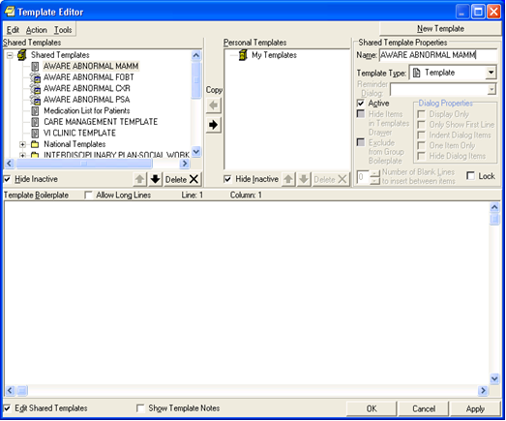

Figure - Template Editor

1. Choose Template Type as “Reminder Dialog”.

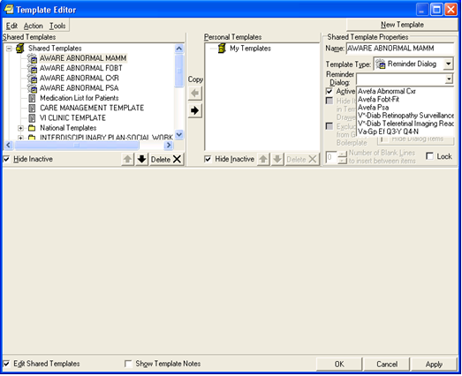

Figure - Choose "Reminder Dialog"

1. Choose Reminder Dialog to be in this case AVEFA ABNORMAL MAMMOGRAM as below:

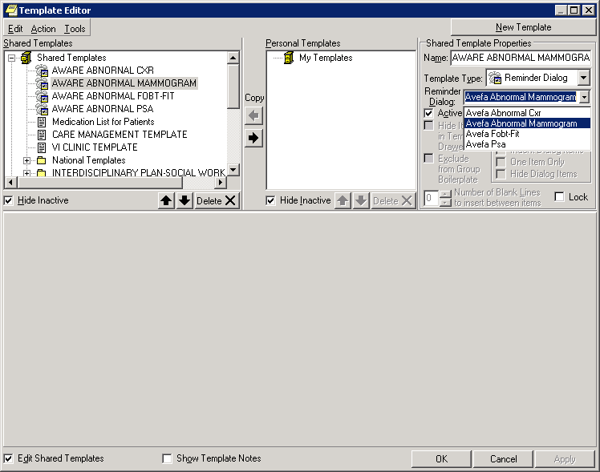

Figure - Reminder Dialog

1. Click “Apply” and then “OK”.
2. Repeat the above steps for other 3 Reminder dialogs.

# 4.4 Edit/Verify Fields for Alert Type Initiation

**A Clinical Application Coordinator is recommended to edit/verify fields in the record entries for template Alert Types through the web-based Knowledge Base (KB) Editor program.**

**A Clinical Application Coordinator is recommended to edit/verify fields in the record entries for tracked alert types for initial testing through the web-based Knowledge Base (KB) Editor program.**

Use KB Editor to edit the critical fields below:

**NOTE:** We recommend that a Clinical Application Coordinator (CAC) complete this step. It can also be accomplished by an OI&T Specialist/Programmer if they have the **VEFA AWARE ADD/EDIT KB RULE** security key.

First, assign the security key **VEFA AWARE ADD/EDIT KB RULE** – This key allows the user to Add/Edit AWARE Knowledge-Based rules using the KB Editor

Assign this to yourself as clinical coordinator, and to other clinical coordinators as needed.

**Use the method below:**

**Menu Management ... [XUMAINT]**

<CPM> Select Menu Management Option: **Key Management ... [XUKEYMGMT]**

<CPM> Select Key Management Option: **Allocation of Security Keys [XUKEYALL]**

Allocate key: **VEFA AWARE ADD/EDIT KB RULE**

Another key:

Holder of key: CLINCOORDINATOR,XXX

Another holder:

You've selected the following keys:

**VEFA AWARE ADD/EDIT KB RULE**

You've selected the following holders:

CLINCOORDINATOR,XXX

You are allocating keys. Do you wish to proceed? YES//

For each Alert type desired to have AWARE monitoring, edit the TIU Template and Reminder Dialog fields with values as shown below:

Edit all the Alert type(s) appropriate for the following Reminder Dialog/TIU Template c combinations:

Reminder Dialog TIU template

(names below) (names below)

**AVEFA FOBT-FIT AWARE ABNORMAL FOBT-FIT**

**AVEFA PSA AWARE ABNORMAL PSA**

**AVEFA ABNORMAL CXR AWARE ABNORMAL CXR**

**AVEFA ABNORMAL MAMMOGRAM AWARE ABNORMAL MAMMOGRAM**

See the KB Editors’ user Guide to use the “Edit” Alert type function from the Alert Tab to edit the Alert types desired among the 4 Alert types available. All Alert types should use 1 of the 4 Reminder Dialog/TIU Template combinations above.

The critical fields for each tracked Alert Type are associated REMINDER Dialog and TIU Template, “ACTIVE” state, and INITIATION DATE for when AWARE monitoring is started for reporting purposes. These fields are determined and set from the web-based Knowledge Base Editor.

See the KB Editors User’s Guide for setup and instructions for setting the “Active” flag for each Alert type your site requires AWARE monitoring. The first time setting of the “Active” flag also sets an “Initiation” date for the Start of AWARE monitoring for an Alert type. See screen below from the Web-based KB editor. The INITIATION DATE will be set automatically for usage upon a first time setting of the “Active” state of the checkbox field. The “Active” state below from the Reminder Dialog tab will allow active critical alert Follow-up Action Tracking via the AWARE DLL connected to a customized AWARE CPRS test executable. See the example below:

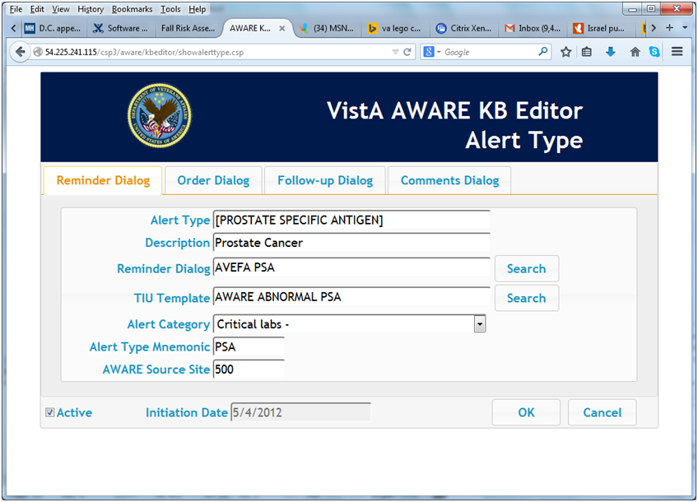

Figure - VistA AWARE KB Editor, Alert Type

# 4.5 Define Site Lab Text Names for making new Alert Types, and Update the Knowledge Base

**We recommend that a Clinical Informatics and/or a Lab Department Chief this first step a.**

a. First, find the particular site specific lab test name(s) to be used for enabled Knowledge Base Alert Type lab alert types Prostate Specific Antigen and/or Occult Blood.

For the lab alert types (PROSTATE SPECFIC ANTIGEN and OCCULT BLOOD) analyze any similarly named lab test names in file 60 LABORATORY TEST for these alert types.

For example with OCCULT BLOOD lab test names as below, choose the one appropriate for the site:

OCCULT BLOOD (SINGLE CARD)

OCCULT BLOOD URINE URINE BLOOD<-this is single lab test with site/specimen

OCCULT BLOOD X3 MAILER 🡨 this is a lab panel for 3 lab tests

OCCULT BLOOD – IMMUNOASSAY

For example with PROSTARE SPECIFIC ANTIGEN lab test name as below, choose the one appropriate for the site:

PSA Prostatic Specific Antigen 🡨 This could be a single lab test with site/specimen.

or

PROSTATE SPECIFIC ANTIGEN

or PROSTATE SPECIFIC ANTIGEN MALES O

Note, the selected site specific lab test names to be used in the next sub-section.

**We recommend that a Clinical Application Coordinator complete this next step b. It can also be accomplished by an OI&T Specialist/Programmer.**

b.) Next, edit the Knowledge base record for each particular alert type name (for example. PSA and OCCULT BLOOD URINE (URINE BLOOD)) using the KB Editor web program. See the KB Editor User’s Guide (T4_AWARE_UserGuide-KBEditor.doc) on instructions for editing an Alert type for OCCULT BLOOD or PROSTATE SPECIFIC ANTIGEN to the site preferred names. Use the “EDIT” Alert type function from the Alert Type Tab to edit the Alert Type name.

Also, if more than 1 type of OCCULT BLOOD or PROSTATE SPECIFIC ANTIGEN lab test is desired, use the “COPY” Alert type function to copy from an existing Alert type to a new one. Change the “*” name to the full name of have the full name of the new additional Alert type. Also, for either a resulting “EDIT” or “COPY” function, always enclose the actual site laboratory test name with a leading ”[“ and trailing “]”. Also, set the “Active” flag for any newly copied Alert type(s) beyond the original 4 Alert types provided with the AWARE install.

Use the full name (like OCCULT BLOOD (SINGLE CARD)), or a Print Name if it exists as an Identifier (such as “URINE BLOOD” from OCCULT BLOOD URINE URINE BLOOD).

The desired Alert lab name(s) representing the OCCULT BLOOD and Prostate Specific Antigen needs to be chosen for the site. In the examples below for using OCCULT BLOOD X3 MAILER and PSA lab test names at your site, use full names such as “OCCULT BLOOD X3 MAILER” and “PSA”, and edit into the VEFA Tracked Critical Alert file using the KB Editor web program. When entering into this Knowledge Base (KB) record enclose these names with brackets (“[“ and “]”). Therefore these resulting names would be “[PSA]” and “[OCCULT BLOOD X3 MAILER]”.

For a laboratory test name of “OCCULT BLOOD – IMMUNOASSAY”, this would be” [OCCULT BLOOD – IMMUNOASSAY]”.

Use the Knowledge Base (KB) Editor to edit the .NAME field on the Alert Type tab for the [OCCULT BLOOD] entry to the appropriate name with preceding “[“ and trailing “]”, i.e. ,” [OCCULT BLOOD – IMMUNOASSAY]”.

If there are more than 2 OCCULT BLOOD lab test names, using the Knowledge Base (KB) Editor from the Alert Type tab, do a “COPY” function from the 1st OCCULT BLOOD test name to new additional one. For example if 2 lab test names used with OCCULT BLOOD are OCCULT BLOOD X3 MAILER and “OCCULT BLOOD FIT SCREEN”, do a copy from “[OCCULT BLOOD X3 MAILER]” to a new Alert type called “[OCCULT BLOOD FIT SCREEN]”, keeping the same characteristics as the first one.

Also, set the “Active” flag for any newly copied Alert type(s) beyond the original 4 Alert types provided with the AWARE install.

**We recommend that an OI&T Specialist/Programmer complete this next step c.**

c. Some lab test names are lab panels or multi-test group, and some are individual lab tests with a site/specimen(s). A Lab Test program to artificially generate critical lab alerts is provided that can be used when that lab test name uses a site/specimen that can allow defining a numerical high critical value. This is important to know these differences as explained under testing section 13 Generate Alerts for Critical Lab Tests and Abnormal Images. An alternate method of lab test alert generation can be used with lab tests w/o a site/specimen.

If the lab test chosen for use in the Test account provides for a site/specimen to allow placement of a numerical high critical value, then follow the steps in this sub-section. Otherwise, if the lab test name preferred is a lab panel, or an X3 lab test such as OCCULT BLOOD X3 MAILER, skip this next sub-section.

Place critical high values for PSA and OCCULT lab tests below if applicable to the particular lab test.

In VistA “VA FileMan

“Enter or Edit File Entries

edit the #60 -- LABORATORY TEST FILE.

Example below is from VA FileMan: PSA

Select VA FileMan <TEST ACCOUNT> Option: enter or Edit File

INPUT TO WHAT FILE: LABORATORY TEST//

EDIT WHICH FIELD: ALL// site

1 SITE NOTES DATE (multiple)

2 SITE/SPECIMEN (multiple)

CHOOSE 1-2: 2 SITE/SPECIMEN (multiple)

EDIT WHICH SITE/SPECIMEN SUB-FIELD: ALL//

THEN EDIT FIELD:

Select LABORATORY TEST NAME: PSA

PSA Prostatic Specific Antigen

Or

PROSTATE SPECIFIC ANTIGEN MALES ONLY

Select SITE/SPECIMEN: SERUM//

SITE/SPECIMEN: SERUM//

REFERENCE LOW: 0.1//

REFERENCE HIGH: 4.0//

CRITICAL LOW: 🡨-----0

CRITICAL HIGH: 🡨----15

INTERPRETATION:

No existing text

Edit? NO//

UNITS: u/mL// ^

Select SITE/SPECIMEN: ^

Select OPTION: INQUIRE TO FILE ENTRIES

OUTPUT FROM WHAT FILE: LAB DATA// 60 LABORATORY TEST (1227 entries)

Select LABORATORY TEST NAME: `5102 PSA Prostatic Specific Antigen

ANOTHER ONE:

STANDARD CAPTIONED OUTPUT? Yes// (Yes)

Include COMPUTED fields: (N/Y/R/B): NO// - No record number (IEN), no Computed Fields

NAME: PSA TYPE: BOTH

SUBSCRIPT: CHEM, HEM, TOX, SER, RIA, ETC.

LOCATION (DATA NAME): CH;500039;1 UNIQUE COLLECTION SAMPLE: NO

LAB COLLECTION SAMPLE: BLOOD FIELD: DD(63.04,500039,

HIGHEST URGENCY ALLOWED: ROUTINE REQUIRED TEST: YES

PRINT NAME: PSA DATA NAME: PROSTHETIC SPECIFIC ANTIGEN

SITE/SPECIMEN: SERUM REFERENCE LOW: 0.1 **🡨**--- multiple for SITE/SPECIMEN

REFERENCE HIGH: 4.0 UNITS: u/mL

CRITICAL LOW: 0

CRITICAL HIGH: 15

COLLECTION SAMPLE: BLOOD MIN VOL (in mls.): 5^

SYNONYM: PSA

SYNONYM: LEDIPSA

GENERAL PROCESSING INST.: This test can be processed for outside labs, as

well as in house

INSTITUTION: XXXXXXXX ACCESSION AREA: JMS YEARLY AREA

VERIFY WKLD CODE: Prostate Specific Ag VERIFY WKLD CODE #: 89760.0000

PROTECT SUFFIX: YES

SITE NOTES DATE: AUG 24, 1999

NOTE: created test for the setup of in-house testing and ledi testing

NATIONAL VA LAB CODE: Prostate Specific Ag

RESULT NLT CODE: Prostate Specific Ag

CATALOG ITEM: YES

Select LABORATORY TEST NAME: OCCULT BLOOD

1 OCCULT BLOOD (SINGLE CARD)

2 OCCULT BLOOD URINE (URINE BLOOD) **🡨-- This one has site/specimen**

3 OCCULT BLOOD X3 MAILER

4 OCCULT BLOOD FIT SCREEN

5 OCCULT BLOOD – IMMUNOASSAY

CHOOSE 1-3: 2 OCCULT BLOOD URINE (URINE BLOOD)

ANOTHER ONE:

STANDARD CAPTIONED OUTPUT? Yes// (Yes)

Include COMPUTED fields: (N/Y/R/B): NO// - No record number (IEN), no Computed Fields

NAME: OCCULT BLOOD URINE TYPE: BOTH

SUBSCRIPT: CHEM, HEM, TOX, SER, RIA, ETC.

LOCATION (DATA NAME): CH;500027;1 UNIQUE COLLECTION SAMPLE: YES

FIELD: DD(63.04,500027, HIGHEST URGENCY ALLOWED: ROUTINE

PRINT NAME: URINE BLOOD PRINT CODE: $J($S(X>0:"POS",1:X),LRCW)

DATA NAME: OCCULT BLOOD

SITE/SPECIMEN: FECES REFERENCE LOW: "NEG." multiple for SITE/SPECIMEN

REFERENCE HIGH: "POS" **🡨** need reference values defined

Critical Low : 0 **🡨**

Critical High : .1 **🡨** **need for testing purposes only in TEST account**

In a production account, would need Critical High as “POS” if wanted for a “Critical lab” type alert

DEFAULT VALUE: "NEG"

COLLECTION SAMPLE: URINE FORM NAME/NUMBER: MISC

INSTITUTION: CAMP MASTER ACCESSION AREA: URINALYSIS

# 4.6 Define Site Abnormal Imaging Alert Category(s) and Procedure Names for making new Alert Types, and update the Knowledge Base

**We recommend that a Clinical Informatics person (or a Champion M.D. medical doctor), and/or a Radiology Department Chief complete this first step a. below:**

a. First, determine the site specific Alert Categories and associated Abnormal Imaging Alert type names associated with Lung Cancer as if they will be used in the Production account. This will be practice preparation for when actually in a Production account. Particular associated Abnormal Imaging procedure(s) with Abnormal Imaging Procedure “CHEST 2 VIEWS FRONT ” should be determined to be used in Knowledge Base Alert type names for “LUNG CANCER” detection.

A site can define new Alert Categories for these Alert type names. One could be called “Amended/Abnormal Imaging Results:”, representing Amended report Imaging Alert types. Or another Alert Category could be "Code 1 TUMOR Abnormal Imaging Results:" as a site specific Alert Category associated with Code 1 Tumors.

Here are some general rules for using site specific Alert Categories and Alert Type Names with Abnormal Imaging Alerts:

1. The Alert category is the first part of the DISPLAY TEXT field in an Alert tracking file entry.

As shown below this is the bolded “**Code 1 TUMOR Abnormal Imaging Results:”.** A second part following a space (“ “) is the Alert type name, in this case it is **“CHEST 2 VIEW**”.

There is a limitation on the size of Alert type names used with a particular Alert Category. The length of the Alert Category + the length of the Alert Type name used with that Alert Category cannot exceed 50 characters. The Alert type name is based on a particular RAD/NUC MED COMMON PROCEDURE file entry that could be associated with a cancer type, in this case “Lung Cancer”. However, the allowed Alert type name’s length found in an Alert Tracking record is bound by a length such that the total length of the Alert Category and Alert Name is less than or equal to 50 characters. In this case above the total length is 38 characters for the Alert Category “**Code 1 TUMOR Abnormal Imaging Results:”**+ 12 characters for the Alert Type Name “**CHEST 2 VIEW”.** The actualRAD/NUC MED COMMON PROCEDURE from which “CHEST 2 VIEW” is based is “CHEST 2 VIEWS PA&LAT”, but since the maximum length allowed such that the total length of Alert category + Alert Type name to not exceed 50 chars, the Alert Type name is a truncated name “CHEST 2 VIEW” whose length is 12 chars.

In the ALERT TRACKING file (example below)

Select ALERT TRACKING NAME: OR,100608,25;991;3150122.162903

NAME: OR,100608,25;991;3150122.162903 DATE CREATED: JAN 22, 2015@16:29:03

PKG ID: OR,25 PATIENT: ONE,OUTPATIENT

GENERATED BY: PROGRAMMER,ONE GENERATED WHILE QUEUED: YES

RETENTION DATE: FEB 05, 2015@16:29:03

DISPLAY TEXT: ONE,OUTPA (O0601): **Code 1 TUMOR Abnormal Imaging Results:** **CHEST 2 VIEW**

FRONT ROUTINE TAG: RPTRAD2

ROUTINE FOR PROCESSING: ORB3FUP2 DATA FOR PROCESSING: 6919591.9099~1

1. These Alert types to be determined for “Lung Cancer” detection are primarily being from the Chest and Thoracic Imaging procedures from the RAD/NUC MED COMMON PROCEDURE file.

The Alert type names selected can be based on the most predominant (frequent) entries found in the Alert Tracking file over an extended date range that are used with an Alert Category or Categories specific for a site.

Examples below for a site:

Select RAD/NUC MED COMMON PROCEDURE: CHEST

1 **CHEST 2 VIEWS PA&LAT** (RAD Detailed) CPT:71020

……….. (RAD Inactive) CPT:71010

6 CHEST OBLIQUE PROJECTIONS (RAD Detailed) CPT:71022

7 CHEST SINGLE VIEW (RAD Detailed) CPT:71010

…….

9 CHEST SPECIAL (LDECUB ETC) (RAD Detailed) CPT:71035

……..

11 CHEST-MULTIPLE VIEW (RAD Broad )

12 CHEST-SINGLE VIEW (RAD Broad )

OR

Select RAD/NUC MED PROCEDURES NAME: CT TH

1 CT THORACIC SPINE W/CONT (RAD Detailed) CPT:72129

2 CT THORACIC SPINE W/O CONT (RAD Detailed) CPT:72128

3 CT THORAX W&W/O CONT (RAD Detailed) CPT:71270

4 CT THORAX W/CONT (RAD Detailed) CPT:71260

5 CT THORAX W/O CONT (CT Detailed) CPT:71250

Etc.

**Now generate a list of Alert Categories and derived Abnormal Imaging Alert Type names suitable for your site with lung cancer detection.** Generate these lists with your own site determination using **a**n example determination for such new Alert Category(s) and derived Alert types as illustrated in **Appendix B Example Determination of Imaging Alert Category and Alert Types for Lung Cancer Detection.**

**We recommend that a Clinical Application Coordinator (CAC) complete this next step b. It can also be accomplished by an OI&T Specialist/Programmer.**

This person needs to beassigned the security key VEFA AWARE ADD/EDIT KB RULE – This key allows the user to Add/Edit AWARE Knowledge-Based rules using the KB Editor.

The KB Editor User’s Guide (T4_AWARE_UserGuide-KBEditor.doc) can be referenced for KB Editor usage regarding such functions as “Adding” an Alert Category, or “Copying” or “Editing an Alert Type.

b.) M**ake a shortcut list of steps to use with the KB Editor for your site in defining specific Alert Categories and Alert Types with lung cancer detection that are derived from the example steps in the Appendix C Example KB Editing Steps with determined Imaging Alert Category and Alert Types for Lung Cancer Detection**. These KB edits should reference the Alert Category and Alert Type lists your Clinical Informatics person (or a Champion M.D. medical doctor), and/or a Radiology Department Chief have made derived from an example determination in the **Appendix Example B Determination of Imaging Alert Category and Alert Types for Lung Cancer Detection.**

After this shortcut list of steps are prepared, follow these steps to make your site KB configurations for the related imaging Alert Category(s) and Alert Type names appropriate for Lung Cancer detection. Again**,** the KB Editor User’s Guide (T4_AWARE_UserGuide-KBEditor.doc) can be referenced for KB Editor usage regarding such functions as “Adding” an Alert Category, or “Copying” or “Editing an Alert Type

# 4.7 Configure the Task Option VEFA AWARE CACHE BUILDER and AWARE CPRS to use the Patient Closeout RPC

**We recommend that an OI&T Specialist complete this section.**

1. The option VEFA AWARE CACHE BUILDER builds the Alert Cache whose data is retrieved by the Alert Cache Viewer application and whose data is captured by the AWARE SQL Transporter for storage of such data into SQL tables for reports managed by the QI Manager. Define and run the option VEFA AWARE CACHE BUILDER on a periodic basis from Task Manager in VistA as shown below (enter time at least 2 minutes ahead of NOW).

**Taskman Management ... [XUTM MGR]**

<CPM> Select Taskman Management Option: ??

**Schedule/Unschedule Options [XUTM SCHEDULE]**

<CPM> Select Taskman Management Option: schedule/Unschedule Options

Select OPTION to schedule or reschedule: **VEFA AWARE ALERT CACHE BUILDER ...OK? Yes// (Yes)**

Edit Option Schedule

Option Name: VEFA AWARE ALERT CACHE BUILDER

Menu Text: AWARE ALERT CACHE BUILDER TASK ID:

__________________________________________________________________________

QUEUED TO RUN AT WHAT TIME: JUL 2,2014@17:03:45

DEVICE FOR QUEUED JOB OUTPUT:

QUEUED TO RUN ON VOLUME SET:

RESCHEDULING FREQUENCY: **60S 🡨 Task will run every 60 seconds**

TASK PARAMETERS:

SPECIAL QUEUEING:

_____________________________________________________________________________

Exit **Save**  Next Page Refresh

Enter a command or '^' followed by a caption to jump to a specific field.

COMMAND: **S** Press <PF1>H for help

**2.Configure AWARE CPRS to use a Patient Closeout Chart RPC**

**NOTE**: We recommend that only an OI&T Specialist/Programmer or Clinical Application Coordinator (CAC) complete this step.

In VISTA, add the “VEFA ORWCOM PT CLSCHART” RPC or “ORWCOM VEFA PT CLSCHART” RPC” to the OR CPRS GUI CHART option depending on which RPC is defined and provided to the site.

INPUT TO WHAT FILE: **OPTION**//

EDIT WHICH FIELD: ALL// **rpc** (multiple)

EDIT WHICH RPC SUB-FIELD: ALL//

THEN EDIT FIELD:

Select OPTION NAME: **OR CPRS GUI CHART** CPRSChart version 1.0.xx.yy

Select RPC: ORVW FACLIST// **VEFA ORWCOM PT CLSCHART** or **“ORWCOM VEFA PT CLSCHART”**

Are you adding 'ORWCOM VEFA PT CLSCHART' as a new RPC (the 2085TH for this OPTION)? No// **y (Yes)**

RPCKEY:

RULES:

Select RPC:

Select OPTION NAME:

# 5.0 AWARE USER SETUP

# 5.1 Enable and Set Up Users with AWARE Linkage

**We recommend that a Clinical Application Coordinator (CAC) complete this step. It can also be done or assisted by an OI&T Specialist/Programmer.**

**A set of primary testing users should be defined by the AWARE Coordinator for allowed AWARE user setup, and responsibility for verifying AWARE functionality in the Test account.**

Specific User setup is needed including that for the Clinical Application Coordinators (CACS), a set of DUMMY, PROVIDER users as providers to use in exercising the Test account, and the actual Test Account users (real physician, nurses, patient safety officers, specific OI&T staff as testers, etc.),

Preferably the DUMMY, PROVIDERS should also belong to the same team (PCMN or OE/RR).

This includes the following users:

DUMMY, PROVIDERA

DUMMY, PROVIDERB

DUMMY, PROVIDERC

DUMMY, PROVIDERD

DUMMY, PROVIDERE

Any DUMMY, PATIENT SAFETY OFFICER

The actual Test users of AWARE in the Test account can belong to teams and some users can be on the same team(s) such as PCMN or OE/RR teams.

Enable and set up users with AWARE linkage to Follow-up Alert Tracking. This can be done by any of the following basis: (by User, Service, Division, or System)

1. Enable new “Patient Chart Closeout” COM connection for users.

Assign user(s) to be enabled to use Follow-up Alert Tracking (FAT) with an enhanced CPRS “Patient Closeout Chart” COM connection as below:

In VISTA,

Select OPTION NAME: XPAR EDIT

1 XPAR EDIT BY TEMPLATE Edit Parameter Values with Template

2 XPAR EDIT KEYWORD Edit Parameter Definition Keyword

3 XPAR EDIT PARAMETER Edit Parameter Values

CHOOSE 1-3: 3 XPAR EDIT PARAMETER Edit Parameter Values

Edit Parameter Values

--- Edit Parameter Values ---

Select PARAMETER DEFINITION NAME: **VEFA ORWCOM PAT CHART CLOSEOUT** COM Object on Patient Chart Closeout

VEFA ORWCOM PAT CHART CLOSEOUT may be set for the following:

1 User USR [choose from NEW PERSON]

3 Service SRV [choose from SERVICE/SECTION]

5 Division DIV [choose from INSTITUTION]

6 System SYS [INNOVATION.DOMAIN.GOV]

Enter selection: 1 User NEW PERSON

Select NEW PERSON NAME: PROVIDER,ONE OP

------ Setting VEFA ORWCOM PAT CHART CLOSEOUT for User: PROVIDER,ONE COM Object: **write4comobject**//

VEFA ORWCOM PAT CHART CLOSEOUT may be set for the following:

1 User USR [choose from NEW PERSON]

3 Service SRV [choose from SERVICE/SECTION]

5 Division DIV [choose from INSTITUTION]

6 System SYS [INNOVATION.DOMAIN.GOV]

Enter selection:

1. Assign “**VEFAALRE”** RPC context option to a user to allow the AWARE DLL to run from CPRS:

In VISTA, assign the RPC context Option, VEFAALRE listed below as secondary menu option to appropriate user(s) of the system. Below are the RPCs of this context option:

NAME: **VEFAALRE** MENU TEXT: VEFA ALRE CONTEXT

TYPE: Broker (Client/Server) CREATOR: PROVIDER,ONE or PROVIDER,EIGHT

RPC: ORWORB FASTUSER

RPC: VEFALKPORD

RPC: VEFA CRIT ALERT TRACKED

RPC: VEFAALERTCAT

RPC: VEFA CRIT ALERT VALUES

RPC: VEFA ALERT DOC ORDERS

RPC: VEFA ALERT DOC FOLLOWUPS

UPPERCASE MENU TEXT: VEFA ALRE CONTEXT

Enter or Edit File Entries

Print File Entries

Search File Entries

Modify File Attributes

Inquire to File Entries

Utility Functions ...

Data Dictionary Utilities ...

Transfer Entries

Other Options ...

You have PENDING ALERTS

Enter "VA to jump to VIEW ALERTS option

Select VA FileMan <TEST ACCOUNT> Option: ^

Core Applications ...

Device Management ...

FM VA FileMan ...

Menu Management ...

Programmer Options ...

Operations Management ...

Spool Management ...

Information Security Officer Menu ...

Taskman Management ...

HL7 Main Menu ...

**User Management ...**

Application Utilities ...

Capacity Planning ...

Manage Mailman ...

You have PENDING ALERTS

Enter "VA to jump to VIEW ALERTS option

Select Systems Manager Menu <TEST ACCOUNT> Option: **USER Management**

Add a New User to the System

**Edit an Existing User**

Deactivate a User

Reactivate a User

List users

User Inquiry

Switch Identities

File Access Security ...

Electronic Signature Block Edit

List Inactive Person Class Users

Manage User File ...

OAA Trainee Registration Menu ...

Person Class Edit

Reprint Access agreement letter

You have PENDING ALERTS

Enter "VA to jump to VIEW ALERTS option

Select User Management <TEST ACCOUNT> Option: **EDIT an Existing User**

Select NEW PERSON NAME: PROVIDER,NINE

1 PROVIDER,NINE TB 10BA1/ADP Scholar Extraordinaire

Press <RETURN> to see more, '^' to exit this list, OR

CHOOSE 1-5: 1 PROVIDER,NINE TB 10BA1/ADP

ire

Edit an Existing User

NAME: **PROVIDER,NINE**  Page 1 of 5

______________________________________________________________________________

NAME... **PROVIDER,NINE**  INITIAL: **TB**

TITLE: NICK NAME: **BUDDIE**

SSN:  DOB:

DEGREE:  MAIL CODE: **10BA1/ADP**

DISUSER:  TERMINATION DATE:

Termination Reason:

PRIMARY MENU OPTION: **ZZ TRAINING MENU**

Select SECONDARY MENU OPTIONS: **VEFAALRE** 🡨---enter

Want to edit ACCESS CODE (Y/N): FILE MANAGER ACCESS CODE:

Want to edit VERIFY CODE (Y/N):

Select DIVISION: **CAMP MASTER**

SERVICE/SECTION: **MEDICINE**

______________________________________________________________________________

COMMAND:

Concerning the VEFAALRE context option assignment, the error message below appears when a user does not have the VEFAALRE context option when using the AWARE CPRS with workstation AWARE DLL, ORWCOM VEFA PAT CHART CLOSEOUT parameterization, and other AWARE configuration parameters.

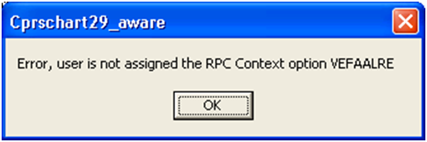

Figure – VEFAALRE Context Option Assignment Error

1. Allow user(s) to have linkage to a TIU Template for each AWARE Reminder Dialog as below:

This can be provided by User, Service, Division, or System assignment. Each user(s) has to have this assigned for each associated AWARE Alert type’s alert’s Reminder Dialog.

AVEFA ABNORMAL CXR reminder dialog LOCAL

AVEFA FOBT-FIT reminder dialog LOCAL

AVEFA PSA reminder dialog LOCAL

AVEFA ABNORMAL MAMMOGRAM reminder dialog LOCAL

Select OPTION NAME: XPAR EDIT

1 XPAR EDIT BY TEMPLATE Edit Parameter Values with Template

2 XPAR EDIT KEYWORD Edit Parameter Definition Keyword

3 XPAR EDIT PARAMETER Edit Parameter Values

CHOOSE 1-3: 3 XPAR EDIT PARAMETER Edit Parameter

Values

Edit Parameter Values

--- Edit Parameter Values ---

Select PARAMETER DEFINITION NAME: **TIU TEMPLATE REMINDER DIALOGS** Reminder Dialogs allows as Templates

TIU TEMPLATE REMINDER DIALOGS may be set for the following:

1 User USR [choose from NEW PERSON]

3 Service SRV [choose from SERVICE/SECTION]

4 Division DIV [choose from INSTITUTION]

5 System SYS [INNOVATION.DOMAIN.GOV]

Enter selection: 1 User NEW PERSON

Select NEW PERSON NAME: PROVIDER,ONE

Setting TIU TEMPLATE REMINDER DIALOGS for User: PROVIDER,ONE

Select Display Sequence: **1**

Are you adding 1 as a new Display Sequence? **Yes// YES**

Display Sequence: **1// 1**

Clinical Reminder Dialog: **AVEFA** 🡨 enter only “AVEFA” to list all 4 of the AWARE Reminder Dialogs.

1 AVEFA ABNORMAL CXR reminder dialog LOCAL

2 AVEFA ABNORMAL MAMMOGRAM reminder dialog LOCAL

3 AVEFA FOBT-FIT reminder dialog LOCAL

4 AVEFA PSA reminder dialog LOCAL

CHOOSE 1-4: 1 **AVEFA ABNORMAL CXR reminder dialog LOCAL**

Select Display Sequence: **2**

Are you adding 2 as a new Display Sequence? **Yes// YES**

Display Sequence: **2// 2**

Clinical Reminder Dialog: **AVEFA ABNORMAL MAMMOGRAM reminder dialog LOCAL**

...OK? **Yes// (Yes)**

Select Display Sequence: **3**

Are you adding 3 as a new Display Sequence? **Yes// YES**

Display Sequence: **3// 3**

Clinical Reminder Dialog: **AVEFA FOBT-FIT reminder dialog LOCAL**

...OK? **Yes// (Yes)**

Select Display Sequence: **4**

Are you adding 4 as a new Display Sequence? **Yes// YES**

Display Sequence: 4// **4**

Clinical Reminder Dialog: **AVEFA PSA reminder dialog LOCAL**

...OK? **Yes// (Yes)**

Select Display Sequence:

TIU TEMPLATE REMINDER DIALOGS may be set for the following:

1 User USR [choose from NEW PERSON]

3 Service SRV [choose from SERVICE/SECTION]

4 Division DIV [choose from INSTITUTION]

5 System SYS [MAE-TEST]

An error message like below will occur if a user invokes a particular Reminder Dialog in CPRS without the TIU TEMPLATE REMINDER DIALOGS parameter enabled for that Reminder Dialog.

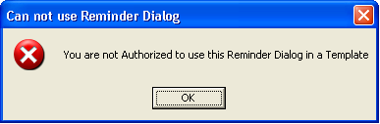

Figure – Cannot Use Reminder Dialog

**NOTE:** Steps 1, 2, and 3 above must be performed for each Provider using AWARE.

# 5.2 Verify Notification Enabling

**We recommend a Clinical Application Coordinator (CAC) determine and verify that actual AWARE providers are allowed to see and process critical lab results and abnormal imaging alerts.**

Notification enabling (critical lab results, abnormal image results, etc., as required)

From CPRS each user must be able to see the critical lab results and abnormal image alerts:

Unless enabled at a higher level, various notification types need to be enabled per user as seen from CPRS Tools menu, Options, Other CPRS parameters, and then Notifications tab as shown below:

This is appropriate to the type of alert required. Critical labs results (action) and Abnl Imaging Reslt, Need Attn (action) need to be turned on for the test examples provided.

For optimal AWARE use, enabling of Critical labs results (action) and Abnl Imaging (action) (action) at the system level is preferable.

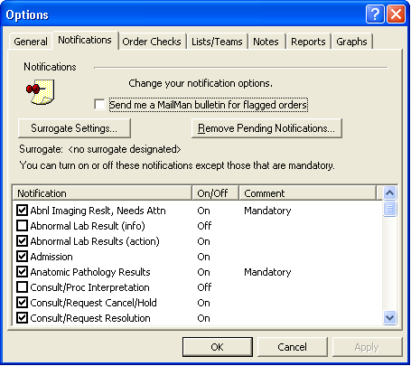

Figure - Options, Notifications

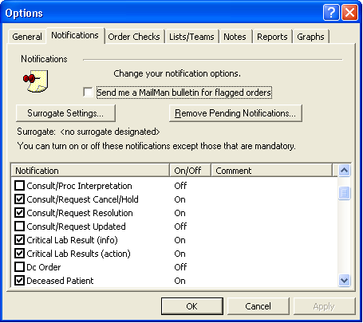

Figure - Options, Notifications (Continued)

# 5.3 Assign Keys, Provider Class, etc.

**We recommend an OI&T Specialist and/or Clinical Application Coordinator (CAC) determine and verify that providers (dummy, provider(s) and actual providers) have the necessary assignments below:**

Assign a user the ORES security key to be able to write orders as a test provider. An ORELSE security key can be given to a non-physician clinician provider. Option OR CPRS GUI CHART CPRSChart version 1.0.x.y should be, or already is assigned to the provider.

Provide a user sufficient USR/ASR user subscription role for creating/editing/and signing progress notes.

Also, assign PROVIDER user class if necessary.

Set a physician provider user’s AUTHORIZED TO WRITE MED ORDERS field in the NEW PERSON file to “YES”. A DEA number can optionally be assigned to a physician provider in a Test account.

Assign a user a New Person class such as Physicians (M.D and D.O.) with an effective date of service, and other appropriate clinician class (such as nursing, etc.) for other type providers belonging to a team such as nurse.

A defined user electronic signature is needed to this provider to be able to sign orders and notes.

# 5.4 Assignment of Keys for Using the Alert Cache Viewer/QI Reporting Tool, and Connecting the Alert Cache Viewer to the Tools Menu of AWARE CPRS

**We recommend an OI&T specialist to do step 1 in this section.**

**We recommend a Clinical Application Coordinator (CAC) to do step 2 in this section.**

1. Assign the VEFA AWARE OWN ALERT key to any provider in this Test account who may want to directly see their own alerts using the Alert Cache Viewer and/or the QI Reporting Tool.

*Note, all physician providers can already directly see their own alerts using the Alert Cache Viewer and/or the QI Reporting Tool by default without having this assignment due to their having a DEA # as a physician.

Assign the VEFA AWARE ALL ALERTS key to any provider such as a Patient Safety Officer to directly see all providers’ AWARE tracked alerts through the Alert Cache Viewer and/or QI Reporting Tool.

Use the method below:

**Menu Management ... [XUMAINT]**

<CPM> Select Menu Management Option: **Key Management ... [XUKEYMGMT]**

<CPM> Select Key Management Option: **Allocation of Security Keys [XUKEYALL]**

Allocate key: **VEFA AWARE ALL ALERT CACHE**

Another key:

Holder of key: CLINCOORDINATOR,XXX

Another holder:

You've selected the following keys:

**VEFA AWARE ALL ALERT CACHE**

You've selected the following holders:

CLINCOORDINATOR,XXX

You are allocating keys. Do you wish to proceed? YES//

1. Connect the Alert Cache Viewer to the Tools Menu of AWARE CPRS.

**Enter by user if preferred**

CPM>D ^XQ1

Select OPTION NAME: **ORW TOOL MENU ITEMS** GUI Tool Menu Items

GUI Tool Menu Items

CPRS GUI Tools Menu may be set for the following:

1 User USR [choose from NEW PERSON]

2 Location LOC [choose from HOSPITAL LOCATION]

2.5 Service SRV [choose from SERVICE/SECTION]

3 Division DIV [choose from INSTITUTION]

4 System SYS [GOLD.VAINNOVATION.US]

9 Package PKG [ORDER ENTRY/RESULTS REPORTING]

Enter selection: **1 User NEW PERSON**

Select NEW PERSON NAME: PROVIDER,SEVEN

----------- Setting CPRS GUI Tools Menu for User: PROVIDER,SEVEN -----------

Select Sequence: 1

Sequence: 1// 1

Name=Command: AWAREAlertViewer=http://54.225.241.115/csptest/aware/alertcache/alert

cache.csp?yiicf=%DUZ Replace 🡨-- enter the web url of the AlertCache Viewer program with appended argument ?Yiicf=%DUZ. See the Administrator to get the web url and for setting Alert Cache Viewer using the T4_AWARE_InstallGde-Kids_CSP doc. (**where 54.225.241.115 is an example site AWARE Windows server ip address. Note, this may be installed on another server for Cache CSP pages such as a Regional Cache CSP server)**

Enter by system if preferred:

CPM>D ^XQ1

Select OPTION NAME: **ORW TOOL MENU ITEMS** GUI Tool Menu Items

GUI Tool Menu Items

CPRS GUI Tools Menu may be set for the following:

1 User USR [choose from NEW PERSON]

2 Location LOC [choose from HOSPITAL LOCATION]

2.5 Service SRV [choose from SERVICE/SECTION]

3 Division DIV [choose from INSTITUTION]

4 System SYS [GOLD.VAINNOVATION.US]

9 Package PKG [ORDER ENTRY/RESULTS REPORTING]

Enter selection**: 4 System GOLD.VAINNOVATION.US**

------- Setting CPRS GUI Tools Menu for System: GOLD.VAINNOVATION.US -------

Select Sequence: ?

Sequence Value

-------- -----

1 VistA Imaging Display="C:\Program Files\VistA\Imaging\MagImageDisplay

2 VistA Imaging Capture="C:\Program Files\VistA\Imaging\TELE19N.EXE" %D

3 Primary Care Almanac(FK)="https://secure.vssc.med.va.gov/pcalmanac/st

4 Primary Care Almanac Test="https://secure.vssc.med.va.gov/pcalmanac/s

Select Sequence: 5

**Are you adding 5 as a new Sequence? Yes// YES**

Sequence: 5// 5

Name=Command: AWAREAlertViewer=http://54.225.241.115/csptest/aware/alertcache/alertcache.csp?yiicf=%DUZ Replace 🡨-- enter the web url of the Alert Cache Viewer program with appended argument ?Yiicf=%DUZ. See the Administrator for getting the web url and or setting up the Alert Cache Viewer using the T4_AWARE_InstallGde-Kids_CSP doc. (**where 54.225.241.115 is an example site specific AWARE Windows server ip address. Note, this may be another server and unique folder for Cache CSP pages such as a Regional Cache CSP server)**

Select Sequence: ?

Sequence Value

-------- -----

1 VistA Imaging Display="C:\Program Files\VistA\Imaging\MagImageDisplay

2 VistA Imaging Capture="C:\Program Files\VistA\Imaging\TELE19N.EXE" %D

3 Primary Care Almanac(FK)="https://secure.vssc.med.va.gov/pcalmanac/st

4 Primary Care Almanac Test="https://secure.vssc.med.va.gov/pcalmanac/s

5 AWAREAlertViewer=http://54.225.241.115/csptest/aware/alertcache/alertcache.csp?yiicf=%DUZ

Select Sequence: ^

CPM>

# 5.5 Set Up CPRS/AWARE to Use FAT COM Object

**An OI&IT Specialist with administrative privileges on a local workstation is required to install the AWARE Executable and DLL on a user workstation. It can also be accomplished by any user who has administrator privileges on a local workstation.**

Set up CPRS/AWARE to use FAT COM object on a local workstation.

## 5.5.1 AWARE CPRS Executable

AWARE contains a customized CPRS executable that must be installed on the user’s workstation in order to see the new AWARE Alert Pop-Up notifications. The custom executable “CPRSChart_AWARE.exe” can be installed manually or automatically using the AWARE InstallShield Wizard.

Download the CPRS_AWARE_v_1_x.zip these files from the AWARE download FTP site (https://54.225.241.69/svn/aware/Deployment/AWARE Version 1.1.x/) to a local location. The Subversion Username is “**awareva**” and the password is “**P@sswd!**”. For use in a VA Beta Test account, extract an AWARE customized CPRS executable for AWARE and auxiliary files Borlndmm.dll, CPRS.cnt, and CPRS.hlp can be placed manually on a test user workstation into an AWARECPRS or other appropriate folder, You can rename the CPRS executable for AWARE as CPRSChart_AWARE.exe. A shortcut should be created pointing to this executable and to the VA Beta test account DSN name or IP (i.e., test.charleston.med.va.gov or test.longbeach.med.va.gov) ,and port number similarly as shown below:

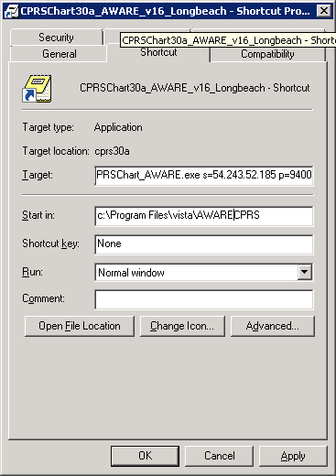

Figure – CPRS

These steps can also be automated through the use of an “install shield” program.

**NOTE**: We recommend that the local IT staff complete this step. The person executing the installations must have full administrator privileges on the local workstations.

Download the AwareDllInstaller.exe file from the AWARE Subversion site ([https://54.225.241.69/svn/aware/Deployment/AWARE Version 1.1.x/AwareDllInstaller.exe](https://54.225.241.69/svn/aware/Deployment/AWARE%20Version%201.1.x/AwareDllInstaller.exe)) to a location on the workstation desktop. Subversion will ask for a username and password for authentication (Figure 6 – Subversion Software Download).

The Subversion Username is “**awareva**” and the password is “**P@sswd!**”.

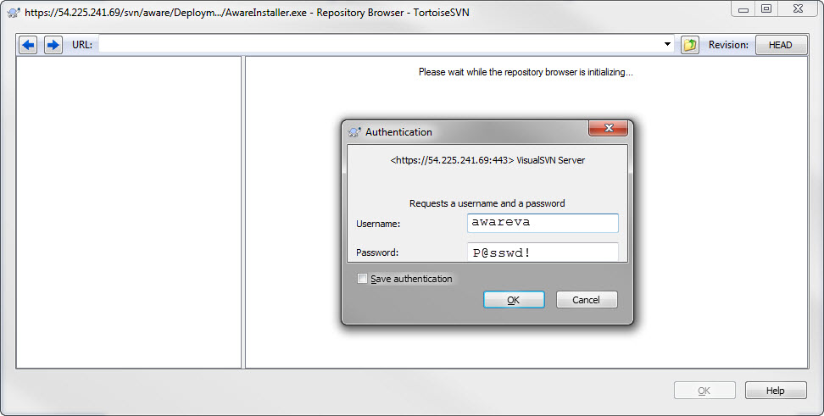

Figure – Subversion Software Download

Validate the properties of the “**AwareDllInstaller.exe**”. Right click the downloaded “AwareDllInstaller.exe” file and select “Properties”. Then click the Unblock button, then click OK (Figure 7).

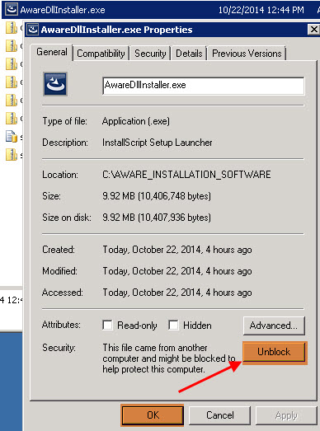

Figure – UnBlock

Right click the downloaded “AwareDllInstaller.exe” file and select “Run as Administrator” (Figure 8).

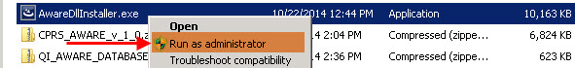

Figure – Run the Aware CPRS Desktop Installer

**Note:** The “**AwareDllInstaller.exe**” must be Run as Administrator to install correctly.

This starts the Aware InstallShield executable. Click the Next button (Figure 9).

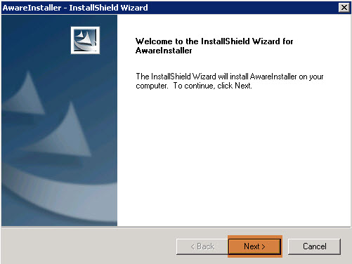

Figure – Aware CPRS Desktop Installer

When prompted, read and accept the terms of the license agreement and click the Next button (Figure 10).

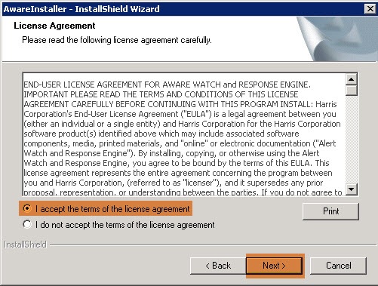

Figure – Accept the Aware License Agreement

Make sure the Install to folder is pointer to C:\Program Files\VistA\AWARECPRS. If not click the Change button and enter the correct path.

Enter the Fully Qualified Domain Name or IP address of the VA Site’s Production VistA Server in the *VistA Server Address:* field and CPRS Port Number in the *VistA Server Port:* field (Figure 11). Then click the Next button.

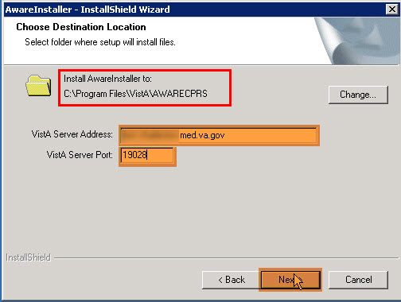

Figure – Enter the sites VistA Server Address and Port Number

Click the Install button to complete the installation (Figure 12).

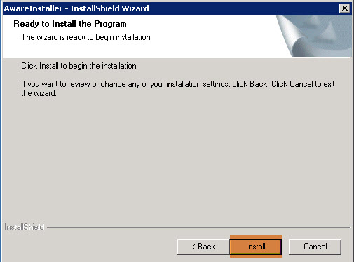

Figure – Complete the Installation

Click the Finish button (Figure 13).

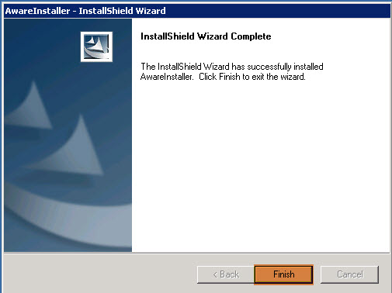

Figure – Finish the Installation

Validate that InstallShield completed correctly. Open Windows Explorer and browse to “C:\Program Files\VistA\AWARECPRS” folder. Check the “AwareDllInstall.log” for any errors. Confirm the following 6 files are in the folder (Figure 14).

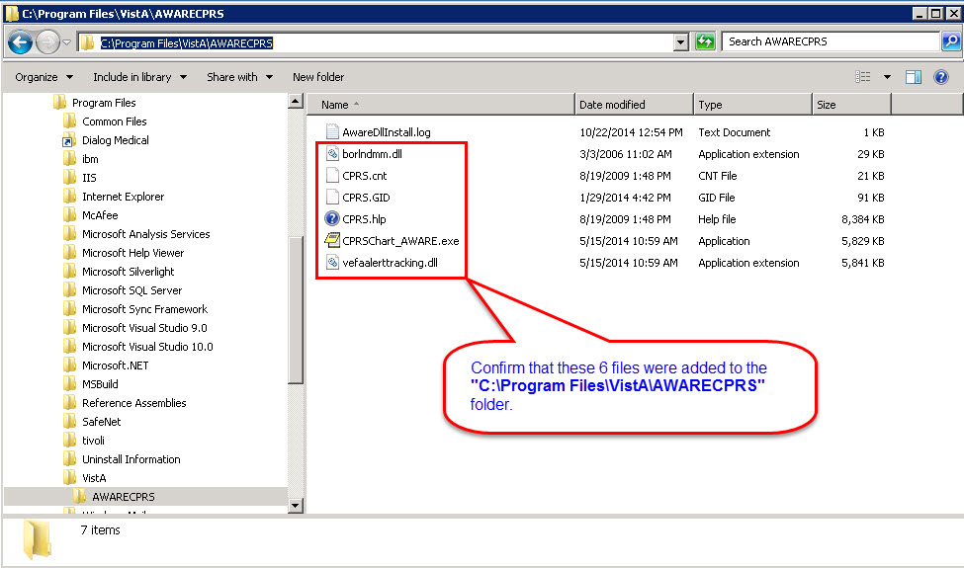

Figure – Validate the Installation

## 5.5.2 AWARE DLL

An AWARE Dynamic Link Library (dll) called vefaalerttracking.dll is a Patient Closeout Chart .com object which adds functionality to CPRS for triggering the AWARE functionality with PROMPT dialog box. Upon proper “Address Now” choice, it automatically triggers the appropriate Reminder Dialog for a tracked alert type having no follow-up action at the time of patient closeout. For use in a VA Beta Test account, this dll could be placed on test user workstation in the same AWARECPRS folder as the executable. Download this file from the AWARE download FTP site ([https://54.225.241.69/svn/aware/Deployment/AWARE Version 1.1.x/](https://54.225.241.69/svn/aware/Deployment/AWARE%20Version%201.1.x/)) from CPRS_AWARE_v_1_x.zip to a local location and move it to an AWARECPRS folder or other appropriate folder for a manual install, or skip this download if already part of an automated complete install through the use of an “install shield” program as explained above in section 6.1 which includes this dll registration.

If done manually, this vefaalerttracking.dll must be registered at a command prompt one time on a workstation using the Windows regsvr32.exe program. For example, if the vefaalerttracking.dll exists in the AWARECPRS folder, then from the AWARECPRS folder “Run as Administrator” (after a right click selection) the following at the workstation’s Command Prompt: >c:\WINDOWS\system32\regsvr32.exe /c vefaalerttracking.dll

The dll can be unloaded using the /u flag.

**NOTE**: We recommend that OI&T staff complete this step. It can also be accomplished by any user who has administrator privileges on the local workstation.

A shortcut for vefaalerttracking.dll can be made and be Run as Administrator on that **workstation** with the following characteristics.

Shortcut Name: Shortcut to REGISTER RUN AS ADMIN vefaalerttracking.dll

Target: C:\WINDOWS\system32\regsvr32.exe /c vefaalerttracking.dll

Start in: c:\Program Files\Vista\AWARECPRS (or in the folder where the vefaalerttracking.dll is located)

Click the “Apply” and “ok” buttons.

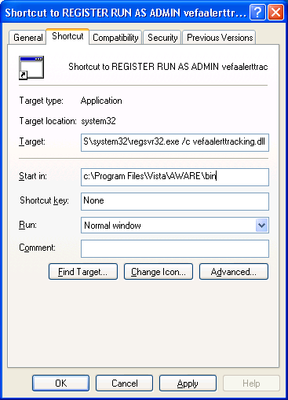

Registration can be done as a local administrator of a workstation or as System Administrator for all workstations. (CheckBox "Protect my computer and data..........." is unclicked as local Administrator)

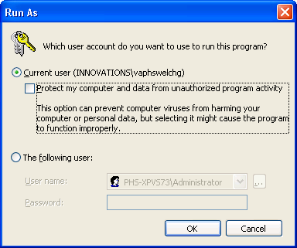

Registration success as below:

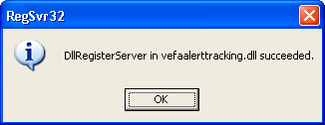

Error Response shown below upon a patent closeout when the vefaalerttracking.dll is not registered on a workstation after all Vista AWARE setup has been made:

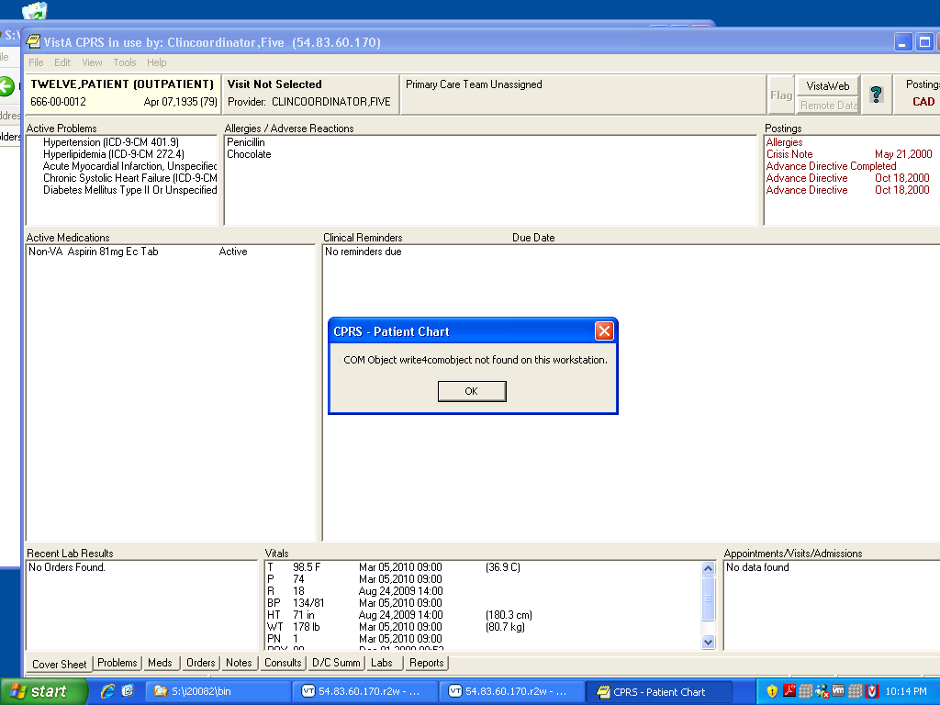

# 6.0 AWARE ALERT GENERATION, TESTING, AND PRODUCTION PREPARATION

# 6.1 Generate Generic Alerts for Critical Lab Values and Abnormal Image Results

**For Test purposes, Test account users can generate Alerts for Critical Lab Tests and Abnormal Images** (for use only in a TEST account).

Assign these options as a Lab technician or Radiologist to make alerts on behalf of a provider (user):

ABIM Critical Abnormal Imaging Results Alert [ZZVEFA ENTER IMAGING ALERT]

CRLA Enter lab data for VEHU patients [ZZVEHU LAB DATA ENTRY]

Create alerts (*only for use in a Test account)

1. Critical Lab Test Alerts

**NOTE:** Assuming OCCULT BLOOD and PROSTATE SPECIFIC ANTIGEN or EQUIVALENT lab test names are in the ORDERABLE ITEMS file and LABORATORY TEST file for generation of lab alerts below.

Provide a Lab tech user having at least the security keys below:  
LRLAB LRLIASON LRSUPER LRVERIFY ORELSE

Provide a Radiology Technician the option   
CRLA Enter lab data for VEHU patients [ZZVEHU LAB DATA ENTRY] to this user.

Make a critical lab test alert as shown in example below for equivalent PROSTATE SPECIFIC ANTIGEN and for OCCULT BLOOD. If either of these lab tests is a lab panel, or does not have a site/specimen for a defined critical lab value, or is a multi-test group (such as OCCULT BLOOD X3 MAILER, or OCCULT BLOOD SINGLE CARD, or OCCULT BLOOD - IMMUNOLOGY), refer to **Appendix D - Alternate Method for Generating Artificial Lab Alerts,**

First logon as this Lab Tech user who will make critical lab alerts. First make alerts for yourselves as Clinical Coordinators if you want to be an AWARE provider. These can also be made on behalf of other test providers (i.e. DUMMY, PROVIDER, etc.)

**For Occult Blood:**

Select Rn Menu <TEST ACCOUNT> Option: CRLA Enter lab data for VEHU patients

Select LABORATORY TEST NAME: URINE BLOOD

The Sample Is URINE,VOIDED (SPOT)

Reference Ranges for this test and Specimen:

Reference Low: "NEG"

Reference High:

Critical Low:

Critical High: .1

If you want the same value for all patients, enter it for both high and low

Enter the low result to enter for this test: .2 🡨 enter value higher than .1

Enter the high result for this test: .3 <- enter value above low result above

A random generator will generate a critical lab alert with a lab value somewhere between the low and high result.

Enter the date/time of collection for all results: N (JUN 26, 2014@14:29)

Provider Selection:

Select a Provider: DUMM,PROV

1 DUMMY,PROVIDER A PAD CAC ATTENDING PHY

2 DUMMY,PROVIDER B PBD CAC ATTENDING

3 DUMMY,PROVIDER C PCD CAC ATTENDING

4 DUMMY,PROVIDER D PDD CAC ATTENDING

5 DUMMY,PROVIDER E PED CAC ATTENDING

CHOOSE 1-5: 2 DUMMY,PROVIDER B PBD CAC ATTENDING

Select patients to enter the selected lab result for. Select numbers between

0 and 950 with the number corresponding to the VeHU patient that you want to

update. For example, choosing number 12 will update VeHU patient twelve

(LAST 6 digits of SSN. Test patients SSN assumed 666 and leading zeros up to 6 digits OR "66600"L4.

Twelve is 666000012 for SSN)

Select patient(s) to be updated: (0-950): 8 (with no leading zeros)

Are you ready to proceed? YES

ZMSHTS,EHYUN F 10-1-36 666000008 NO NSC VETERAN

>>> Active Patient Record Flag(s):

<MISSING PATIENT> CATEGORY II

<PAIN CONTRACT> CATEGORY II

Do you wish to view active patient record flag details? Yes// N (No)

WARNING : ** This patient has been flagged with a Bad Address Indicator.

Enrollment Priority: Category: IN PROCESS End Date:

*** Patient Requires a Means Test ***

Primary Means Test Required from JUN 28,2013

Enter <RETURN> to continue.

MEANS TEST REQUIRED

PROVIDER=DUMMY,PROVIDER B

LAB Order number: 14876

Enter Report Routing Location: 🡨enter a location in the Hospital location file (i.e. ZAAATEST CLINIC FOR ITD-X ).

Print labels on: LABLABEL2PRT// ^

ACCESSION: UR 0626 1 <1341770001>

URINE BLOOD URINE,VOIDED (SPOT) URINE

Work Load Area: URINALYSIS🡨 or other location

ACCESSION: UR 0626 1

6/26 14:29d

URINE BLOOD .3 H*

Verified!

************************************************

**For Prostate Specific Antigen (PSA):**

Select OPTION NAME: ZZVEHU LAB DATA ENTRY Enter lab data for VEHU patients

Enter lab data for VEHU patients

Select LABORATORY TEST NAME: PSA **PROSTATE SPECIFIC ANTIGEN** PSA

Is BLOOD GOLD TOP the correct sample to collect? Y//

Reference Ranges for this test and Specimen:

Reference Low: 0.1

Reference High: 4.0

Critical Low:

Critical High: 15

If you want the same value for all patients, enter it for both high and low

Enter the low result to enter for this test: 16 **🡨-- greater than 15**

Enter the high result for this test: 18 🡨**----greater than 15 so that any randomly selected value(s) between 16 and 18 are all > 15 as a Critical High value.**

Enter the date/time of collection for all results: **NOW** (AUG 18, 2011@00:37)

Provider Selection:

Select a Provider: PROVIDER,NINE

Select patients to enter the selected lab result for. Select numbers between 0 and 950 with the number corresponding to the VeHU patient that you want to update. **For example, choosing number 12 will update VeHU patient twelve (LAST 6 digits of SSN. Test patients SSN assumed 666 and leading zeros up to 6 digits or "66600"_"L4.".L4 as last four. Twelve is with a patient with SSN 666000012**

Select patient(s) to be updated: (0-950): 9 **🡨--enter last part of SSN. ( no leading zeros)**

Are you ready to proceed? YES

EIGHT,PATIENT 4-7-35 666000008 YES SC VETERAN SMB SMB

Enrollment Priority: Category: IN PROCESS End Date:

PROVIDER=PROVIDER,NINE

LAB Order number: 17657

Work Load Area: URINALYSIS 🡨 or other location

ACCESSION: JMS 11 13 <7811000013>

PROSTATE SPECIFIC ANTIGEN BLOOD SERUM

GENERAL PROCESSING INST.: This test can be processed for outside labs, as

well as in house

ACCESSION: JMS 11 13

8/18 00:37d

PROSTATE SPECIFIC ANTIGEN 13 H* u/mL

Verified!

************************************************

2. Abnormal Imaging Alerts

Make an Abnormal Imaging Result Alert for a Chest X-Ray and Mammogram:

Assign this user the option **ABIM** Critical Abnormal Imaging Results Alert [**VEFA ENTER IMAGING ALERT**]

Logon to as this Radiologist user who will make abnormal imaging alert(s) on behalf of another provider.

Select OPTION NAME: VEFA

1 VEFA ALERT TRACKING REPORTING FAT Alert Tracking Reporting

2 VEFA ENTER IMAGING ALERT Critical Abnormal Imaging Results

CHOOSE 1-8: 2 VEFA ENTER IMAGING ALERT Critical Abnormal Imaging Results Alert

Critical Abnormal Imaging Results Alert

Select Patient for Imaging Alert : FIVE,PA **🡨---select patient**

1 FIVE,PATIENT 4-7-35 666000005 YES SC VETERAN

CHOOSE 1-5: 1 FIVE,PATIENT 4-7-35 666000005 YES SC VETERAN

Enrollment Priority: GROUP 3 Category: IN PROCESS End Date:

Provider Selection:

Select a Provider: PROVIDER,FIVE **🡨--Enter on behalf of a provider**

DO YOU WANT CHEST 2 VIEWS FRONT AND LATERAL? Yes// N (No) or (Yes) **🡨--- choose this one** for an abnormal Chest X-Ray alert

DO YOU WANT MAMMOGRAM BILAT? Yes// Y (Yes) or (No) **🡨-- or choose this one for An abnormal Mammogram alert**

DO YOU WANT AMENDED CHEST 2 VIEWS FRONT AND LATERAL"? Yes// N (No) or (Yes) **🡨--- choose this one** for an abnormal Amended Chest X-Ray alert

# 

# 6.2 Exercise the System with Initial Testing

**For AWARE users,** exercise system with pop-up of “Prompt” display for allowing redirection in CPRS to do Follow-up Action Tracking.

1. Log in into CPRSChart_AWARE.exe through the desktop shortcut pointing to Beta test site test account for user PROVIDER,NINE (or to whom the example PSA alert for a test patient (i.e. EIGHT,PATIENT) is made such as the Clinical Coordinator who does this initial setup and who can assume a provider role).

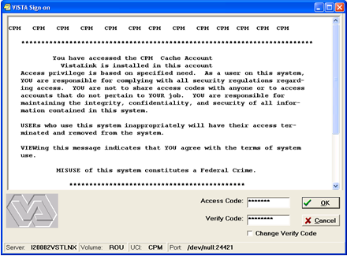

Figure - VistA Sign

1. Bring up patient EIGHT,PATIENT. Note the existing PROSTATE SPECIFIC ANTIGEN alert, which will need addressing in the alert window.

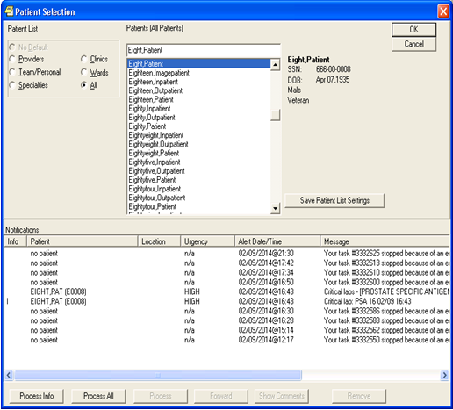

Figure - Patient Selection

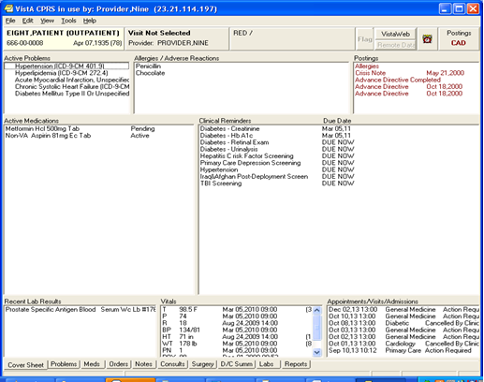

Figure - VistA CPRS In Use

1. Select a new Patient from menu bar.

See AWARE prompt popup as PROSTATE SPECIFIC ANTIGEN alert is detected for previous patient EIGHT, PATIENT with no follow-up action taken on patient closeout.

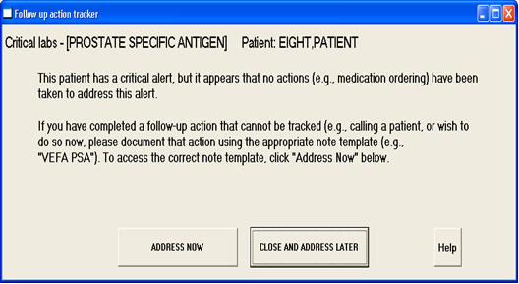

Figure - Follow-Up Action Tracker

1. Click the “Address Now” button to allow automatic CPRS redirection for performing follow-up actions for this type of tracked critical alert. The following window appears.

**NOTE:** The redirected and selected VEFA PSA TIU Template and connected Reminder Dialog on the left hand side of screen.

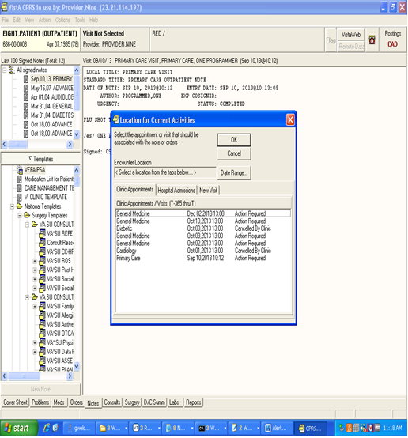

Figure - Location for Current Activities

For the location to use with subsequent progress note/reminder dialog execution, the “New Visits” tab automatically appears.

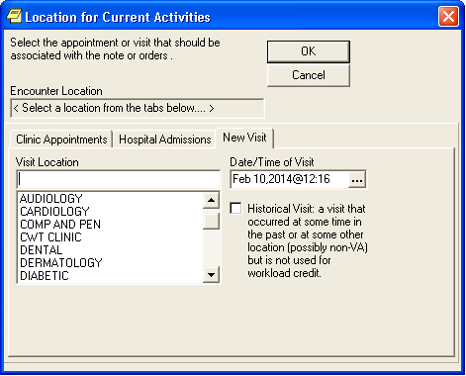

Figure - Location for Current Activities

1. Pick a location and progress note title for doing any subsequent follow-up actions.

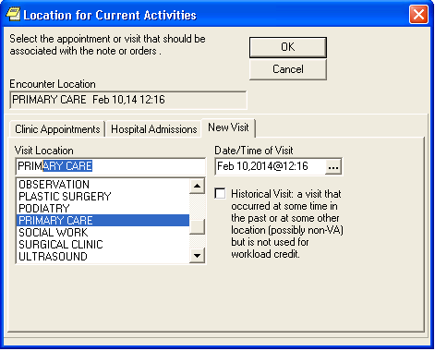

Figure - Location for Current Activities (Continued)

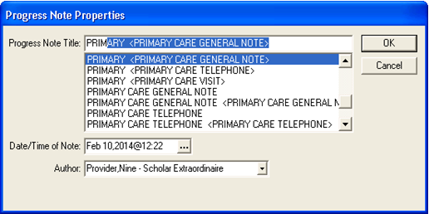

Figure - Progress Note Properties

The reminder dialog appears as shown below for doing follow-up actions:

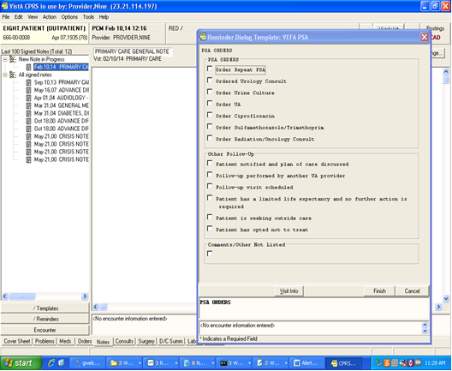

Figure - Reminder Dialog

See the AWARE User Interface Document (T4_AWARE_UserIFDoc) for additional information on using the system.

# 6.3 Validation with Re-Factoring Preparation of Reminder Dialogs Data

**A Clinical Informatics (i.e. an AWARE Champion M.D medical doctor), or Clinical Application Coordinator (CAC) is recommended to re-factor four delivered Template Reminder dialogs.** This is for using site customized orderable items, consults, procedures and order dialogs. These Reminder dialogs include those for critical lab results for PSA as [PROSTATE SPECIFIC ANTIGEN] and the FOBT (Fecal Occult Blood Test) as [OCCULT], and Abnormal Imaging results for Chest X-Ray and Mammograms.

A re-factoring of the Four Delivered Template Reminder Dialogs can be done in the Test account as practice preparation for performing these steps in a Production account**.**

Example Orderable item, Order Dialog, and Reminder Dialog Site Customization steps are provided in **Appendix E – Example of Site Customization with Reminder Dialogs.**

**Be sure to verify the re-factored AWARE Reminder Dialogs as designed and customized for your site’s equivalent orders, consults, procedures, orderable items, lab test names, etc., and as would be run in a Production account. Take into consideration any complementary Reminder dialogs already in place whose follow-up actions can replace or add to the ones in the AWARE Reminder dialogs used with your site Alert types.** This can be tested for adequacy either with CPRS re-direction to these re-factored Reminder Dialogs from associated TIU Templates in a Shared TIU Template folder with prompted AWARE test alerts, or from exercising the re-factored AWARE Alert Type Reminder Dialogs directly as standalone Reminder Dialogs from associated TIU Templates in a Shared TIU Template folder.

This concludes the Configuration, User Setup, Validation and Testing steps described in this document for use in the Test account.

# 7.0 APPENDICIES

# 7.1 Appendix A – Example of Reminder Dialog Exchange to Load & Install Reminder Dialogs

**NOTE: We recommend that a OI&T Specialist or a Clinical Application Coordinator (CAC) complete these steps.**

Perform the steps described below in order to load each of the four (4) Reminder Dialog .PRD files.

Do both steps in this Appendix:

a. Load and Install Reminder Dialogs

and

b. Change the status of Reminder Dialogs from a “Disabled’ to an “Active” state.

1. **Load and Install Reminder Dialogs**

Last login: Wed Jun 4 15:18:48 2014 from 173.252.156.129

Node: I20082VSTLNX, Instance: CACHEINV

Username: CacheMgr

Password: *********

Select OPTION NAME: ?

Answer with OPTION NAME, or UPPERCASE MENU TEXT

Do you want the entire 11028-Entry OPTION List? N (No)

Select OPTION NAME: TRAINING

1 TRAINING DATA ENTRY FOR MFH HBHC MFH TRAINING INPUT Training Data

Entry for MFH

**2 TRAINING MENU ZZ TRAINING MENU Training Menu**

3 TRAINING RECORDS ESP TRAINING MENU Training Records

4 TRAINING REPORT BY SERVICE PRSE-SERV-TRAIN-RPT Training Report by Service

5 TRAINING REPORT BY UNIT/SVC. C NURSE-PR-MILOC Training Report by Unit/Svc. Category

CHOOSE 1-5: 2 ZZ **TRAINING MENU Training Menu**

PCE Basic PCE Hands-On ...

AICS Encounter Forms ...

OE CPRS Manager Menu ...

**PX Reminder Managers Menu ...**

XX General Parameter Tools ...

Select Training Menu <TEST ACCOUNT> Option: **PX Reminder Managers Menu**

CF Reminder Computed Finding Management ...

RM Reminder Definition Management ...

SM Reminder Sponsor Management ...

TXM Reminder Taxonomy Management ...

TRM Reminder Term Management ...

LM Reminder Location List Management ...

**RX Reminder Exchange**

RT Reminder Test

OS Other Supporting Menus ...

INFO Reminder Information Only Menu ...

DM Reminder Dialog Management ...

CP CPRS Reminder Configuration ...

RP Reminder Reports ...

MST Reminders MST Synchronization Management ...

PL Reminder Patient List Menu ...

PAR Reminder Parameters ...

ROC Reminder Order Check Menu ...

XM Reminder Extract Menu ...

GEC GEC Referral Report

Select Reminder Managers Menu <TEST ACCOUNT> Option: **RX Reminder Exchange**

Clinical Reminder Exchange Jun 04, 2014@16:44:50 Page: 1 of 7

Exchange File Entries.

Item Entry Source Date Packed

1 COLONOSCOPY F/U REMINDER1 GUILLORY@VA PACIFIC I 05/18/2010@12:28

2 COLONOSCOPY REPEAT DUE1 GUILLORY@VA PACIFIC I 05/18/2010@12:24

3 DEPRESSION/PTSD REMINDER TERM VOLPP@NORTHERN CAL 02/26/2010@12:07

UPDATES - PATCH 17

4 GMTS FOR HRMH THOMPSON@SALT LAKE CI 12/01/2011@11:10

5 NATIONAL BLOOD PRESSURE MONTGOMERY@TUSCALOOSA 04/05/2011@13:20

CHANGES

6 PXRM*2*17 COMPUTED FINDINGS REDINGTON@SALT LAKE CI 01/26/2010@11:49

7 VA BRANCHING LOGIC REMINDER VOLPP@NORTHERN CAL 09/13/2010@11:42

UPDATES OEF/OIF

+ + Next Screen - Prev Screen ?? More Actions >>>

CFE Create Exchange File Entry IH Installation History

CHF Create Host File LHF Load Host File

CMM Create MailMan Message LMM Load MailMan Message

DFE Delete Exchange File Entry LR List Reminder Definitions

IFE Install Exchange File Entry RI Reminder Definition Inquiry

Select Action: Next Screen// LHF

Enter a path: C:/HFS/// /srv/vista/inv/dat2/AVEFAC_PSA.PRD

A host file is a file on your host system.

A complete host file consists of a path, file name, and extension.

A path consists of a device and directory name.

The default extension is PRD.

The default path is C:/HFS/

Enter a path: C:/HFS/// USER$:[VMSUSERS.XXXXX**]🡨-example path address (either a VMS or Linux account as appropriate site folder holding the .PRD files)**

The following PRD files were found in /srv/vista/inv/dat2/

AVEFAC_ABNORMAL_CXR.PRD

AVEFAC_ABNORMAL_MAMMOGRAM.PRD

AVEFAC_FOBT-FIT.PRD

AVEFAC_PSA.PRD

Enter a file name: AVEFAC_PSA.PRD

Clinical Reminder Exchange Jun 04, 2014@16:48:34 Page: 1 of 8

Host file USER$:[VMSUSERS.XXXXX]AVEFAC_PSA.PRD <successfully loaded.

Item Entry Source Date Packed

1 AVEFAC PSA INNOVATIONS@CAMP MASTER 05/19/2014@19:47

2 COLONOSCOPY F/U REMINDER1 GUILLORY@VA PACIFIC I 05/18/2010@12:28

3 COLONOSCOPY REPEAT DUE1 GUILLORY@VA PACIFIC I 05/18/2010@12:24

4 DEPRESSION/PTSD REMINDER TERM VOLPP@NORTHERN CAL 02/26/2010@12:07

UPDATES - PATCH 17

5 GMTS FOR HRMH THOMPSON@SALT LAKE CI 12/01/2011@11:10

6 NATIONAL BLOOD PRESSURE MONTGOMERY@TUSCALOOSA 04/05/2011@13:20

CHANGES

7 PXRM*2*17 COMPUTED FINDINGS REDINGTON@SALT LAKE CI 01/26/2010@11:49

8 VA BRANCHING LOGIC REMINDER VOLPP@NORTHERN CAL 09/13/2010@11:42

+ + Next Screen - Prev Screen ?? More Actions >>>

CFE Create Exchange File Entry IH Installation History

CHF Create Host File LHF Load Host File

CMM Create MailMan Message LMM Load MailMan Message

DFE Delete Exchange File Entry LR List Reminder Definitions

IFE Install Exchange File Entry RI Reminder Definition Inquiry

Select Action: Next Screen// IFE Install Exchange File Entry

Select Entry(s): (1-8): 1

Exchange File Components Jun 04, 2014@16:49:58 Page: 1 of 9

Component Category Exists

Source: INNOVATIONS,VHA at CAMP MASTER

Date Packed: 05/19/2014@19:47:47

Package Version: 2.0P30

Description:

AVEFAC PSA

Non-exchangeable order dialog(s):

-----------------------------------------------------------------------

Name: VEFA URINALYSIS

Type: Quick Order

Display Text: Urinalysis

Display Group: CHEMISTRY

Package: LAB SERVICE

Lab Test: VEFA URINALYSIS

Collected By: Send patient to lab

Collection Sample: URINE

+ Enter ?? for more actions >>>

IA Install all Components IS Install Selected Component

Select Action: Next Screen//

Exchange File Components Jun 04, 2014@16:50:23 Page: 2 of 9

+ Component Category Exists

Specimen: URINE

How often: ONCE

-----------------------------------------------------------------------

-----------------------------------------------------------------------

Name: VEFA CIPROFLOXACIN

Type: Quick Order

Display Text: Ciprofloxacin

Display Group: OUTPATIENT MEDICATIONS

Package: OUTPATIENT PHARMACY

Medication: CIPROFLOXACIN TAB 500MG

Instructions: 500MG ORAL (BY MOUTH)

Pick Up: WINDOW

Priority: ROUTINE

Comments: Take as directed.

-----------------------------------------------------------------------

-----------------------------------------------------------------------

+ + Next Screen - Prev Screen ?? More Actions >>>

IA Install all Components IS Install Selected Component

Select Action: Next Screen//

Exchange File Components Jun 04, 2014@16:50:46 Page: 3 of 9

+ Component Category Exists

Name: VEFA Urine Culture and Susceptibility

Type: Quick Order

Display Text: Urine Culture and Susceptibility

Display Group: MICROBIOLOGY

Package: LAB SERVICE

Lab Test: VEFA CULTURE & SUSCEPTIBILITY

Collected By: Send patient to lab

Collection Sample: URINE

Specimen: URINE

How often: ONCE

-----------------------------------------------------------------------

-----------------------------------------------------------------------

Name: VEFA SULFAMETHOXAZOLE/TRIMETHOPRIM

Type: Quick Order

Display Text: Trimethoprim/Sulfamethoxazole

Display Group: OUTPATIENT MEDICATIONS

+ + Next Screen - Prev Screen ?? More Actions >>>

IA Install all Components IS Install Selected Component

Select Action: Next Screen//

Exchange File Components Jun 04, 2014@16:51:13 Page: 4 of 9

+ Component Category Exists

Package: OUTPATIENT PHARMACY

Medication: SULFAMETHOXAZOLE/TRIMETHOPRIM TAB

Dispense Drug: SULFAMETHOXAZOLE 800/TRIMETH 160MG TAB

Instructions: 1 TABLET SULFAMETHOXAZOLE 800/TRIMETH 160MG TAB OR

Days Supply: 5

Quantity: 10

Refills: 0

Pick Up: MAIL

Priority: ROUTINE

-----------------------------------------------------------------------

-----------------------------------------------------------------------

Name: VEFA Urology Consult

Type: Quick Order

Display Text: Urology Consult

Display Group: CONSULTS

Package: CONSULT/REQUEST TRACKING

+ + Next Screen - Prev Screen ?? More Actions >>>

IA Install all Components IS Install Selected Component

Select Action: Next Screen//

Exchange File Components Jun 04, 2014@16:51:39 Page: 5 of 9

+ Component Category Exists

Consult to Service/Specialty: SURGERY

Consult Type: Urology

Reason for Request: Abnormal PSA

Category: OUTPATIENT

Urgency: ROUTINE

Earliest appropriate date:TODAY

Place of Consultation: Consultant's Choice

Provisional Diagnosis: Elevated PSA

-----------------------------------------------------------------------

-----------------------------------------------------------------------

Name: VEFA PSA

Type: Quick Order

Display Text: Reorder PSA

Display Group: CHEMISTRY

Package: LAB SERVICE

Lab Test: VEFA PROSTATE SPECIFIC ANTIGEN

+ + Next Screen - Prev Screen ?? More Actions >>>

IA Install all Components IS Install Selected Component

Select Action: Next Screen//

Exchange File Components Jun 04, 2014@16:51:55 Page: 6 of 9

+ Component Category Exists

Collected By: Send patient to lab

Collection Sample: BLOOD

Specimen: SERUM

How often: NOW

-----------------------------------------------------------------------

-----------------------------------------------------------------------

Name: VEFA RADIATION ONCOLOGY CONSULT

Type: Quick Order

Display Text: Radiation/Oncology Consult

Display Group: CONSULTS

Package: CONSULT/REQUEST TRACKING

Consult to Service/Specialty: VEFA RADIOLOGY ONCOLOGY

Reason for Request: SUSPICIOUS PSA

Urgency: ROUTINE

Earliest appropriate date:TODAY

Place of Consultation: Consultant's Choice

+ + Next Screen - Prev Screen ?? More Actions >>>

IA Install all Components IS Install Selected Component

Select Action: Next Screen//

Exchange File Components Jun 04, 2014@16:52:12 Page: 7 of 9

+ Component Category Exists

Provisional Diagnosis: Suspicious PSA

-----------------------------------------------------------------------

Keywords:

PSA

Components:

ORDER DIALOG

VEFA RADIATION ONCOLOGY CONSULT

VEFA SULFAMETHOXAZOLE/TRIMETHOPRIM

VEFA PSA

VEFA CIPROFLOXACIN

VEFA URINALYSIS

VEFA Urine Culture and Susceptibility

VEFA Urology Consult

+ + Next Screen - Prev Screen ?? More Actions >>>

IA Install all Components IS Install Selected Component

Select Action: Next Screen//

Exchange File Components Jun 04, 2014@16:52:39 Page: 8 of 9

+ Component Category Exists

ORDER DIALOG

VEFA RADIATION ONCOLOGY CONSULT X

VEFA SULFAMETHOXAZOLE/TRIMETHOPRIM X

VEFA PSA X

VEFA CIPROFLOXACIN X

VEFA URINALYSIS X

VEFA Urine Culture and Susceptibility X

VEFA Urology Consult X

ORDERABLE ITEMS

VEFA RADIOLOGY ONCOLOGY X

VEFA SULFAMETHOXAZOLE/TRIMETHOPRIM TAB X

VEFA PROSTATE SPECIFIC ANTIGEN X

VEFA CIPROFLOXACIN TAB X

VEFA URINALYSIS X

VEFA CULTURE & SUSCEPTIBILITY X

VEFA Urology Consult X

HEALTH FACTORS

1 REMINDER FACTORS X

2 AW500 PSA OTHER FOLLOW-UP COMMENTS

3 AW500 PSA PAT OPTED NO TREATMENT

4 AW500 PSA PAT NO LONGER IN CARE

5 AW500 PSA LIMITED LIFE

+ + Next Screen - Prev Screen ?? More Actions >>>

IA Install all Components IS Install Selected Component

Select Action: Next Screen//

Exchange File Components Jun 04, 2014@17:36:42 Page: 9 of 9

+ Component Category Exists

6 AW500 PSA FOLLOWUP

7 AW500 PSA REFER TO ANOTHER VA PROVIDER

8 AW500 PSA DISCUSSED WITH PAT

9 AW500 PSA RADIATION ONCOLOGY CSLT

10 AW500 PSA SULFAMETHOXAZOLE/TRIMETH

11 AW500 PSA REORDER PSA

12 AW500 PSA ORDER CIPROFLOACIN

13 AW500 PSA ORDER URINALYSIS

14 AW500 PSA ORDER URINE CULTURE

15 AW500 PSA ORDER UROLOGY CONSULT

REMINDER DIALOG

16 AVEFA PSA

+ Next Screen - Prev Screen ?? More Actions >>>

IA Install all Components IS Install Selected Component

Select Action: Quit// IA

Exchange File Components Nov 24, 2014@15:08:47 Page: 8 of 9

All dialog components for AVEFA PSA are new.

Install reminder dialog and all components with no further changes: Y//

+ Component Category Exists

ORDERABLE ITEMS

VEFA RADIOLOGY ONCOLOGY X

VEFA SULFAMETHOXAZOLE/TRIMETHOPRIM TAB X

VEFA PROSTATE SPECIFIC ANTIGEN X

VEFA CIPROFLOXACIN TAB X

VEFA URINALYSIS X

VEFA CULTURE & SUSCEPTIBILITY X

VEFA Urology Consult X

+ + Next Screen - Prev Screen ?? More Actions >>>

IA Install all Components IS Install Selected Component

Select Action: Next Screen// IA Install all Components

HEALTH FACTORS entry named REMINDER FACTORS already exists and the

packed component is identical, skipping.

HEALTH FACTORS entry AW500 PSA OTHER FOLLOW-UP COMMENTS is NEW,

what do you want to do?

Select one of the following:

C Create a new entry by copying to a new name

I Install

Q Quit the install

S Skip, do not install this entry

Enter response: I// Install

HEALTH FACTORS entry AW500 PSA PAT OPTED NO TREATMENT is NEW,

what do you want to do?

Select one of the following:

C Create a new entry by copying to a new name

I Install

Q Quit the install

S Skip, do not install this entry

Enter response: I// Install

HEALTH FACTORS entry AW500 PSA PAT NO LONGER IN CARE is NEW,

what do you want to do?

Select one of the following:

C Create a new entry by copying to a new name

I Install

Q Quit the install

S Skip, do not install this entry

Enter response: I// Install

HEALTH FACTORS entry AW500 PSA LIMITED LIFE is NEW,

what do you want to do?

Select one of the following:

C Create a new entry by copying to a new name

I Install

Q Quit the install

S Skip, do not install this entry

Enter response: I// nstall

HEALTH FACTORS entry AW500 PSA FOLLOWUP is NEW,

what do you want to do?

Select one of the following:

C Create a new entry by copying to a new name

I Install

Q Quit the install

S Skip, do not install this entry

Enter response: I// nstall

HEALTH FACTORS entry AW500 PSA REFER TO ANOTHER VA PROVIDER is NEW,

what do you want to do?

Select one of the following:

C Create a new entry by copying to a new name

I Install

Q Quit the install

S Skip, do not install this entry

Enter response: I// nstall

HEALTH FACTORS entry AW500 PSA DISCUSSED WITH PAT is NEW,

what do you want to do?

Select one of the following:

C Create a new entry by copying to a new name

I Install

Q Quit the install

S Skip, do not install this entry

Enter response: I// nstall

HEALTH FACTORS entry AW500 PSA RADIATION ONCOLOGY CSLT is NEW,

what do you want to do?

Select one of the following:

C Create a new entry by copying to a new name

I Install

Q Quit the install

S Skip, do not install this entry

Enter response: I// nstall

HEALTH FACTORS entry AW500 PSA SULFAMETHOXAZOLE/TRIMETH is NEW,

what do you want to do?

Select one of the following:

C Create a new entry by copying to a new name

I Install

Q Quit the install

S Skip, do not install this entry

Enter response: I// nstall

HEALTH FACTORS entry AW500 PSA REORDER PSA is NEW,

what do you want to do?

Select one of the following:

C Create a new entry by copying to a new name

I Install

Q Quit the install

S Skip, do not install this entry

Enter response: I// nstall

HEALTH FACTORS entry AW500 PSA ORDER CIPROFLOACIN is NEW,

what do you want to do?

Select one of the following:

C Create a new entry by copying to a new name

I Install

Q Quit the install

S Skip, do not install this entry

Enter response: I// nstall

HEALTH FACTORS entry AW500 PSA ORDER URINALYSIS is NEW,

what do you want to do?

Select one of the following:

C Create a new entry by copying to a new name

I Install

Q Quit the install

S Skip, do not install this entry

Enter response: I// nstall

HEALTH FACTORS entry AW500 PSA ORDER URINE CULTURE is NEW,

what do you want to do?

Select one of the following:

C Create a new entry by copying to a new name

I Install

Q Quit the install

S Skip, do not install this entry

Enter response: I// nstall

HEALTH FACTORS entry AW500 PSA ORDER UROLOGY CONSULT is NEW,

what do you want to do?

Select one of the following:

C Create a new entry by copying to a new name

I Install

Q Quit the install

S Skip, do not install this entry

Enter response: I// nstall

ialog Components Nov 28, 2015@18:13:44 Page: 1 of 4

Packed reminder dialog: AVEFA PSA

Item Seq. Dialog Findings Type Exists

1 AVEFA PSA dialog

2 1 AVEFA PSA ORDERS GROUP group

Finding: *NONE*

3 1..5 AW500 PSA REPEAT PSA element X

Finding: VEFA PSA (ORDER DIALOG) X

Add. Finding: AW500 PSA REORDER PSA (HEALTH FACTOR) X

4 1.1 AW500 PSA ORDER UROLOGY CONSULT element X

Finding: VEFA Urology Consult (ORDERABLE ITEM) X

Add. Finding: AW500 PSA ORDER UROLOGY CONSULT (HEALTH X

FACTOR)

5 1.2 AW500 PSA ORDER URINE CULTURE element X

Finding: VEFA Urine Culture and Susceptibility (ORDER X

DIALOG)

Add. Finding: AW500 PSA ORDER URINE CULTURE (HEALTH FACTOR) X

+ + Next Screen - Prev Screen ?? More Actions

DD Dialog Details DT Dialog Text IS Install Selected

DF Dialog Findings DU Dialog Usage QU Quit

DS Dialog Summary IA Install All

Select Action: Next Screen//

Dialog Components Nov 28, 2015@18:14:55 Page: 2 of 4

Packed reminder dialog: AVEFA PSA

+Item Seq. Dialog Findings Type Exists

6 1.4 AW500 PSA ORDER URINALYSIS element X

Finding: VEFA URINALYSIS (ORDERABLE ITEM) X

Add. Finding: AW500 PSA ORDER URINALYSIS (HEALTH FACTOR) X

7 1.5 AW500 PSA ORDER CIPRO element X

Finding: VEFA CIPROFLOXACIN (ORDER DIALOG) X

Add. Finding: AW500 PSA ORDER CIPROFLOACIN (HEALTH FACTOR) X

8 1.6 AW500 PSA ORDER BACTRIM element X

Finding: VEFA SULFAMETHOXAZOLE/TRIMETHOPRIM (ORDER DIALOG) X

Add. Finding: AW500 PSA SULFAMETHOXAZOLE/TRIMETH (HEALTH X

FACTOR)

9 1.7 AW500 PSA RADIATION ONCOLOGY CSLT element X

Finding: VEFA RADIATION ONCOLOGY CONSULT (ORDER DIALOG) X

Add. Finding: AW500 PSA RADIATION ONCOLOGY CSLT (HEALTH X

FACTOR)

+ + Next Screen - Prev Screen ?? More Actions

DD Dialog Details DT Dialog Text IS Install Selected

DF Dialog Findings DU Dialog Usage QU Quit

DS Dialog Summary IA Install All

Select Action: Next Screen//

Dialog Components Nov 28, 2015@18:15:37 Page: 3 of 4

Packed reminder dialog: AVEFA PSA

+Item Seq. Dialog Findings Type Exists

10 2 AVEFA PSA OTHER FOLLOW-UP GROUP group

Finding: *NONE*

11 2.1 AW500 PSA DISCUSSED WITH PAT element X

Add. Finding: AW500 PSA DISCUSSED WITH PAT (HEALTH FACTOR) X

12 2.2 AW500 PSA REFER TO ANOTHER VA PROV element X

Add. Finding: AW500 PSA REFER TO ANOTHER VA PROVIDER X

(HEALTH FACTOR)

13 2.3 AW500 PSA FOLLOWUP element X

Add. Finding: AW500 PSA FOLLOWUP (HEALTH FACTOR) X

14 2.4 AW500 PSA LIMITED LIFE element X

Add. Finding: AW500 PSA LIMITED LIFE (HEALTH FACTOR) X

15 2.5 AW500 PSA PAT NO LONGER IN CARE element X

Add. Finding: AW500 PSA PAT NO LONGER IN CARE (HEALTH X

FACTOR)

16 2.6 AW500 PSA PAT OPTED NO TREAT element X

+ + Next Screen - Prev Screen ?? More Actions

DD Dialog Details DT Dialog Text IS Install Selected

DF Dialog Findings DU Dialog Usage QU Quit

DS Dialog Summary IA Install All

Select Action: Next Screen//

ialog Components Nov 28, 2015@18:16:15 Page: 4 of 4

Packed reminder dialog: AVEFA PSA

+Item Seq. Dialog Findings Type Exists

Add. Finding: AW500 PSA PAT OPTED NO TREATMENT (HEALTH X

FACTOR)

17 3 AVEFA PSA OTHER FOLLOWUP COMMENTS GROUP group X

Finding: *NONE*

18 3.1 AW500 PSA OTHER FOLLOW-UP COMMENTS element X

Add. Finding: AW500 PSA OTHER FOLLOW-UP COMMENTS (HEALTH X

FACTOR)

19 PXRM COMMENT prompt X

+ Next Screen - Prev Screen ?? More Actions

DD Dialog Details DT Dialog Text IS Install Selected

DF Dialog Findings DU Dialog Usage QU Quit

DS Dialog Summary IA Install All

Select Action: Quit//IA

ll dialog components for AVEFA PSA already exist.

Components not used by any other dialogs.

Install reminder dialog and all components with no further changes: Y//

Dialog Components Nov 24, 2014@15:16:02 Page: 1 of 4

Packed reminder dialog: AVEFA PSA

Item Seq. Dialog Findings Type Exists

1 AVEFA PSA dialog X

2 1 AVEFA PSA ORDERS GROUP group X

Finding: *NONE*

3 1..5 AW500 PSA REPEAT PSA element X

Finding: VEFA PSA (ORDER DIALOG) X

Add. Finding: AW500 PSA REORDER PSA (HEALTH FACTOR) X

4 1.1 AW500 PSA ORDER UROLOGY CONSULT element X

Finding: VEFA Urology Consult (ORDERABLE ITEM) X

Add. Finding: AW500 PSA ORDER UROLOGY CONSULT (HEALTH X

FACTOR)

5 1.2 AW500 PSA ORDER URINE CULTURE element X

Finding: VEFA Urine Culture and Susceptibility (ORDER X

DIALOG)

Add. Finding: AW500 PSA ORDER URINE CULTURE (HEALTH FACTOR) X

+ + Next Screen - Prev Screen ?? More Actions

DD Dialog Details DT Dialog Text IS Install Selected

DF Dialog Findings DU Dialog Usage QU Quit

DS Dialog Summary IA Install All

Select Action: Next Screen//Q

Exchange File Components Nov 28, 2015@18:19:19 Page: 9 of 9

+ Component Category Exists

6 AW500 PSA FOLLOWUP X

7 AW500 PSA REFER TO ANOTHER VA PROVIDER X

8 AW500 PSA DISCUSSED WITH PAT X

9 AW500 PSA RADIATION ONCOLOGY CSLT X

10 AW500 PSA SULFAMETHOXAZOLE/TRIMETH X

11 AW500 PSA REORDER PSA X

12 AW500 PSA ORDER CIPROFLOACIN X

13 AW500 PSA ORDER URINALYSIS X

14 AW500 PSA ORDER URINE CULTURE X

15 AW500 PSA ORDER UROLOGY CONSULT X

REMINDER DIALOG

16 AVEFA PSA X

+ Next Screen - Prev Screen ?? More Actions >>>

IA Install all Components IS Install Selected Component

Select Action: Quit//Q

1. **Change the status of Reminder Dialogs from a “Disabled’ to an “Active” state**

D ^XQ1

PXRM DIALOG MANAGEMENT Reminder Dialog Management

DP Dialog Parameters ...

DI Reminder Dialogs

DR Dialog Reports ...

IA Inactive Codes Mail Message

You have PENDING ALERTS

Enter "VA to jump to VIEW ALERTS option

Select Reminder Dialog Management <TEST ACCOUNT> Option: DI Reminder Dialogs

Dialog List May 13, 2015@10:57:15 Page: 1 of 14

REMINDER VIEW (ALL REMINDERS BY NAME)

Item Reminder Name Linked Dialog Name & Dialog Status

1 ARD 00 ANTICOAGULATION AFIB

2 BL PCLC NEEDED

3 BL PHQ9 NEEDED UPDATE PHQ2 INFO TEXT Disabled

4 BL SUICIDE RISK NEEDED

5 CHF OUTPATIENT EDUCATION

6 CRD 00 ANTICOAG FOR AFIB

7 CRD ANTICOAG FOR AFIB

8 DIABETES - RETINAL EXAM PH DIABETIC RETINAL EXAM

9 DIABETES CREATININE

10 DIABETES HBA1C

11 DIABETES URINALYSIS

12 EVALUATION OF + DEPRESSION SCREEN EVALUATION OF + DEPRESSION Disabled

13 EVALUATION OF + PTSD SCREEN EVALUATION OF + PTSD SCREEN Disabled

14 HEP C - DZ & TRANSMISSION EDUCATIO

+ Enter ?? for more actions >>>

AD Add Reminder Dialog PT List/Print All QU Quit

CV Change View RN Name/Print Name

Select Item: Next Screen//CV

+ Enter ?? for more actions

D Reminder Dialog

R Reminders

RG Result Group (Mental Health)

RE Result Element (Mental Health)

TYPE OF VIEW: R// D Reminder Dialogs

Dialog List May 13, 2015@11:22:25 Page: 1 of 6

DIALOG VIEW (REMINDER DIALOGS - SOURCE REMINDER NAME)

Item Reminder Dialog Name Source Reminder Status

1 ARD 227H ANTICOAGULATION FOR AFIB ARD 00 ANTICOAGULATION AF

2 AVEFA ABNORMAL CXR <---AWARE Reminder Dialog *NONE*

3 AVEFA ABNORMAL MAMMOGRAM <---AWARE Reminder Dialog *NONE*

4 AVEFA FOBT-FIT <----AWARE Reminder Dialog *NONE*

5 AVEFA PSA <----- AWARE Reminder Dialog *NONE*

6 CRD ANTICOAG AFIB/FLUTTER ARD 00 ANTICOAGULATION AF

7 EMPLOYEE PPD - >13MONTHS *NONE*

8 EVALUATION OF + DEPRESSION SCREEN EVALUATION OF + DEPRESSIO Disabled

9 EVALUATION OF + PTSD SCREEN EVALUATION OF + PTSD SCRE Disabled

10 HEP C - EVALUATION FOR TREATMENT HEP C - EVALUATION FOR TR Linked

11 HEP C RISK FACTOR SCREENING HEP C RISK FACTOR SCREENI Linked

12 HEP C TESTING FOR AT RISK PT HEP C TESTING FOR AT RISK Linked

13 HIV RPR *NONE* Disabled

14 HTN AND BP>140 OR >90 HTN AND BP>140 OR >90 Linked

+ Enter ?? for more actions >>>

AD Add Reminder Dialog PT List/Print All QU Quit

CV Change View RN Name/Print Name

Select Item: Next Screen//

Dialog List Nov 28, 2015@18:21:51 Page: 1 of 6

DIALOG VIEW (REMINDER DIALOGS - SOURCE REMINDER NAME)

Item Reminder Dialog Name Source Reminder Status

1 ARD 227H ANTICOAGULATION FOR AFIB ARD 00 ANTICOAGULATION AF

2 AVEFA ABNORMAL CXR *NONE* Disabled

3 AVEFA ABNORMAL MAMMOGRAM *NONE* Disabled

4 AVEFA FOBT-FIT *NONE* Disabled

5 AVEFA PSA *NONE* Disabled

6 CRD ANTICOAG AFIB/FLUTTER ARD 00 ANTICOAGULATION AF

7 EMPLOYEE PPD - >13MONTHS *NONE*

8 EVALUATION OF + DEPRESSION SCREEN EVALUATION OF + DEPRESSIO Disabled

9 EVALUATION OF + PTSD SCREEN EVALUATION OF + PTSD SCRE Disabled

10 HEP C - EVALUATION FOR TREATMENT HEP C - EVALUATION FOR TR Linked

11 HEP C RISK FACTOR SCREENING HEP C RISK FACTOR SCREENI Linked

12 HEP C TESTING FOR AT RISK PT HEP C TESTING FOR AT RISK Linked

13 HIV RPR *NONE* Disabled

14 HTN AND BP>140 OR >90 HTN AND BP>140 OR >90 Linked

+ + Next Screen - Prev Screen ?? More Actions >>>

AD Add Reminder Dialog PT List/Print All QU Quit

CV Change View RN Name/Print Name

Select Item: Next Screen// 5

Dialog Edit List Nov 28, 2015@18:22:02 Page: 1 of 3

REMINDER DIALOG NAME: AVEFA PSA (Disabled)

Item Seq. Dialog Summary

1 1 Group: AVEFA PSA ORDERS GROUP

2 1..5 Element: AW500 PSA REPEAT PSA

3 1.1 Element: AW500 PSA ORDER UROLOGY CONSULT

4 1.2 Element: AW500 PSA ORDER URINE CULTURE

5 1.4 Element: AW500 PSA ORDER URINALYSIS

6 1.5 Element: AW500 PSA ORDER CIPRO

7 1.6 Element: AW500 PSA ORDER BACTRIM

8 1.7 Element: AW500 PSA RADIATION ONCOLOGY CSLT

+ + Next Screen - Prev Screen ?? More Actions >>>

DD Detailed Display DT Dialog Text

DP Progress Note Text ED Edit/Delete Dialog

Select Item: Next Screen// ED Edit/Delete Dialog

NAME: AVEFA PSA//

DISABLE: DISABLE AND SEND MESSAGE// @ CLASS: LOCAL//

SURE YOU WANT TO DELETE? Y (Yes)

CLASS: LOCAL//

SPONSOR:

REVIEW DATE:

SOURCE REMINDER:

Select SEQUENCE: 3//

SEQUENCE: 3//

DIALOG ELEMENT/GROUP: AVEFA PSA OTHER FOLLOWUP COMMENTS GROUP

//

//

Select SEQUENCE:

PATIENT SPECIFIC:

Dialog Edit List May 13, 2015@11:42:03 Page: 1 of 3

ialog Edit List Nov 28, 2015@18:26:25 Page: 1 of 3

REMINDER DIALOG NAME: AVEFA PSA

Item Seq. Dialog Summary

1 1 Group: AVEFA PSA ORDERS GROUP

2 1..5 Element: AW500 PSA REPEAT PSA

3 1.1 Element: AW500 PSA ORDER UROLOGY CONSULT

4 1.2 Element: AW500 PSA ORDER URINE CULTURE

5 1.4 Element: AW500 PSA ORDER URINALYSIS

6 1.5 Element: AW500 PSA ORDER CIPRO

7 1.6 Element: AW500 PSA ORDER BACTRIM

8 1.7 Element: AW500 PSA RADIATION ONCOLOGY CSLT

+ + Next Screen - Prev Screen ?? More Actions >>>

ADD Add Element/Group DS Dialog Summary INQ Inquiry/Print

CO Copy Dialog DO Dialog Overview QU Quit

DD Detailed Display DT Dialog Text

DP Progress Note Text ED Edit/Delete Dialog

Select Item: Next Screen// Q

# 7.2 Appendix B – Example Determination of Imaging Alert Category and Alert Types for Lung Cancer Detection

1. For an example site there is an Alert Category for Code 1 Tumors with the name "Code 1 TUMOR Abnormal Imaging Results:". This is part of a class III modification at this site for Tumor classification. There is also another related Alert Category for a Code 1 Abnormal classification with the name “Code 1 Abnormal Imaging Results:”. However, for the initial introduction of AWARE, the Radiology Department wanted to use only the “Code 1 Tumors” classification. However, there are also some National guidelines to use certain specific diagnostic code markings with a standard Alert Category named “Abnl Imaging Reslt, Needs Attn:”. A Clinical Champion at this site has indicated a desire to use these National guidelines even though it is not implemented now for the main hospital at this site, but is partially in place for use with Tele Radiology.
2. There is recognition that there are possible problems with recognizing critical alerts with Tele Radiology where National Guidelines are needed to be used with alert processing with an Alert Category “Abnl Imaging Reslt, Needs Attn:”. Personnel have indicated these types are lacking follow-ups. Also for this site, this Alert Category is spelled “Abnl Imaging Reslt, Needs Atn:”. This evidently is defined in the Radiology package.
3. As an interim and present solution, it was thought that both the Abnormal Imaging Alerts

with the class III "Code 1 TUMOR Abnormal Imaging Results:" Alert category, as well as the "Abnl Imaging Reslt: Needs Atn:" Alert Category could both be processed together. This would only be for Lung Cancer Alert type names, one of the 4 types being initially introducing with AWARE. Limitations of Alert type names are taken in consideration as truncated names are sometimes necessary with a restriction of Alert Category name + length of any Alert type name being limited to a total of 50 characters. Also only specific Chest X-ray and Thoracic CAT Scan procedure Alert types would be monitored. Filtering for specific diagnostic code(s) for the "Abnl Imaging Reslt: Needs Atn:” Alert Category would not be considered as all codes would be allowed (even though this filtering of is desired by the site).

1. Alert types determined for "Code 1 TUMOR Abnormal Imaging Results:" Alert Category:

For imaging tests regarding early detection of Lung Cancer there are some frequently occurring Chest and Thoracic imaging Alert types which have been found in this site’s Alert Tracking file in the site Production mirrored Test account. These Alert type names as truncated in the Alert Type part of the “Menu Text” field in entries in the Alert Tracking file found with Alert category "Code 1 TUMOR Abnormal Imaging Results:" include the following:

"CHEST 2 VIEW",

"CHEST OBLIQU",

"CHEST SINGLE", and

"CHEST SPECIA" as truncated names in Alert Tracking file entries standing for such procedure(s) as below:

CHEST 2 VIEWS PA&LAT (Alert type name of "CHEST 2 VIEW")

CHEST OBLIQUE PROJECTIONS (Alert type name of “CHEST OBLIQU")

CHEST SINGLE VIEW (Alert type name of "CHEST SINGLE”)

CHEST SPECIAL (LDECUB ETC) (Alert type name of “CHEST SPECIA")

The total length for this chosen Alert Category and each these Alert type truncated names is 38 characters + 12 characters which equals 50 chars (the maximum # of characters).

A Clinical Champion M.D medical doctor has also indicated that additional CAT scans have been used for heavy smokers, and for previously diagnosed Lung cancer patients who are in remission, but could have reoccurrence.

These Alert type names associated with particular procedures for the above including thoracic imaging procedures are the following:

“CT THORAX W/",

"CT THORAX W&",

"CT THORACIC S" as truncated names in Alert Tracking file entries standing for such procedure as below:

CT THORACIC SPINE W & W/O CONTRAST (Alert type name of “CT THORACIC S")

CT THORACIC SPINE W/CONT (Alert type name of “CT THORACIC S")

CT THORACIC SPINE W/O CONT (Alert type name of "CT THORACIC S")

CT THORAX W&W/O CONT (Alert type name of "CT THORAX W&")

CT THORAX W/CONT (Alert type name of " CT THORAX W/")

CT THORAX W/O CONT (Alert type name of " CT THORAX W/")

5. Alert types determined for "Abnl Imaging Reslt: Needs Atn:" Alert Category:

These Alert type names as truncated in the Alert Type part of the “Menu Text” field in entries in the Alert Tracking file found with Alert category "Abnl Imaging Reslt: Needs Atn:" Alert Category include the following:

"CHEST 2 VIEWS PA&LAT",

"CHEST OBLIQUE PROJEC",

"CHEST SINGLE VIEW", and

"CHEST SPECIAL (LDECU", as truncated names in Alert Tracking file entries standing for such procedure(s) as below:

CHEST 2 VIEWS PA&LAT (Alert type name of "CHEST 2 VIEWS PA&LAT")

CHEST OBLIQUE PROJECTIONS (Alert type name of "CHEST OBLIQUE PROJEC")

CHEST SINGLE VIEW (Alert type name of "CHEST SINGLE VIEW")

CHEST SPECIAL (LDECUB ETC) (Alert type name of "CHEST SPECIAL (LDECU)”)

A Clinical Champion M.D medical doctor has also indicated that additional CAT scans have been used for heavy smokers, and for previously diagnosed Lung cancer patients who are in remission, but could have reoccurrence.

Some of these Alert type names associated with particular procedures for the above including thoracic imaging procedures are the following:

“CT THORAX W/O CONT",

"CT THORAX W&W/O CONT",

"CT THORACIC SPINE W/O",

“CT THORAX W/CONT, and

“CT THORACIC SPINE W&” as truncated names in Alert Tracking file entries standing for such procedure as below:

CT THORACIC SPINE W&W/O CONTRAST (Alert type name of "CT THORACIC SPINE W&")

CT THORACIC SPINE W/O CONT (Alert type name of "CT THORACIC SPINE W/O")

CT THORAX W&W/O CONT (Alert type name of "CT THORAX W&W/O CONT")

CT THORAX W/CONT (Alert type name of " CT THORAX W/CONT")

CT THORAX W/O CONT (Alert type name of “CT THORAX W/O CONT ")

# 7.3 Appendix C – Example KB Editing Steps from determined Imaging Alert Category and Alert Types for Lung Cancer Detection

1. First, make an additional new Alert Category name for Code 1 Tumors with the name "Code 1 TUMOR Abnormal Imaging Results:". Add this new Alert Category entry from the “Alert Category” tab using the “Add” feature. See “Add” below.

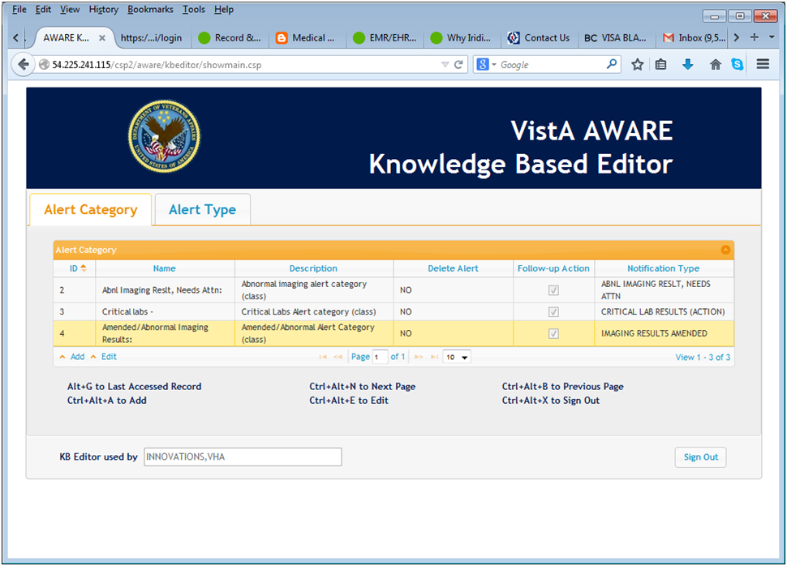

Set the Description as “Code 1 TUMOR Abnormal Imaging Results:”, set “No” for “Delete Alert”, and Check the “Upon Follow-up Action” Checkbox, and set the Notification type to “ABNL IMAGING RESLT, NEEDS ATTN” (25)

1. Next, make an additional new Alert Category name for Abnl Imaging Reslt: Needs Atn:” with the name "Abnl Imaging Reslt: Needs Atn:". Add this new Alert Category entry from the “Alert Category” tab using the “Add” feature. See “Add” above. Set the Description as “Abnl Imaging Reslt: Needs Atn”, set “No” for “Delete Alert”, and Check the “Upon Follow-up Action” Checkbox, and set the Notification type to “ABNL IMAGING RESLT, NEEDS ATTN” (25)
2. Use the “COPY” function of the KB editor to make a copy of the Alert type “CHEST 2 VIEWS FRONT” to each of these truncated names for Alert Type from the two lists below:

"CHEST 2 VIEW",

"CHEST OBLIQU",

"CHEST SINGLE",

"CHEST SPECIA"

and

“CT THORAX W/",

"CT THORAX W&",

"CT THORACIC S"

Specify the Alert Category for each new Alert type as "Code 1 TUMOR Abnormal Imaging Results:". All the characteristics of first Alert Type “CHEST 2 VIEWS FRONT” are carried to the elements of the newly “copied” Alert type including orders/follow-up/comment actions and same TIU Template and associated Reminder Dialog.

1. Use the “COPY” function of the KB editor to make a copy of the Alert type “CHEST 2 VIEWS FRONT” to each of these truncated names for Alert Type from the two lists below:

"CHEST 2 VIEWS PA&LAT",

"CHEST OBLIQUE PROJEC",

"CHEST SINGLE VIEW",

"CHEST SPECIAL (LDECU",

and

“CT THORAX W/O CONT",

"CT THORAX W&W/O CONT",

"CT THORACIC SPINE W/O"

“CT THORAX W/CONT “

“CT THORACIC SPINE W&”

Specify the Alert Category for each new Alert type as the "Abnl Imaging Reslt: Needs Atn:".

All the characteristics of first Alert Type “CHEST 2 VIEWS FRONT” are carried to the elements of the newly “copied” Alert type including orders/follow-up/comment actions and same TIU Template and associated Reminder Dialog.

# 7.4 Appendix D – Alternate Method for Generating Artificial Lab Alerts

**This can be done using CPRS and VistA for users referencing this Appendix from section 15 Generate Generic Alerts for Critical Lab Values and Abnormal Image Results as an alternate method for generating lab alerts**.

1. Log in to CPRS as a Provider and select a test patient. Then click the Orders tab and click Lab Tests from the left side. Select the Visit Location and click the OK button.

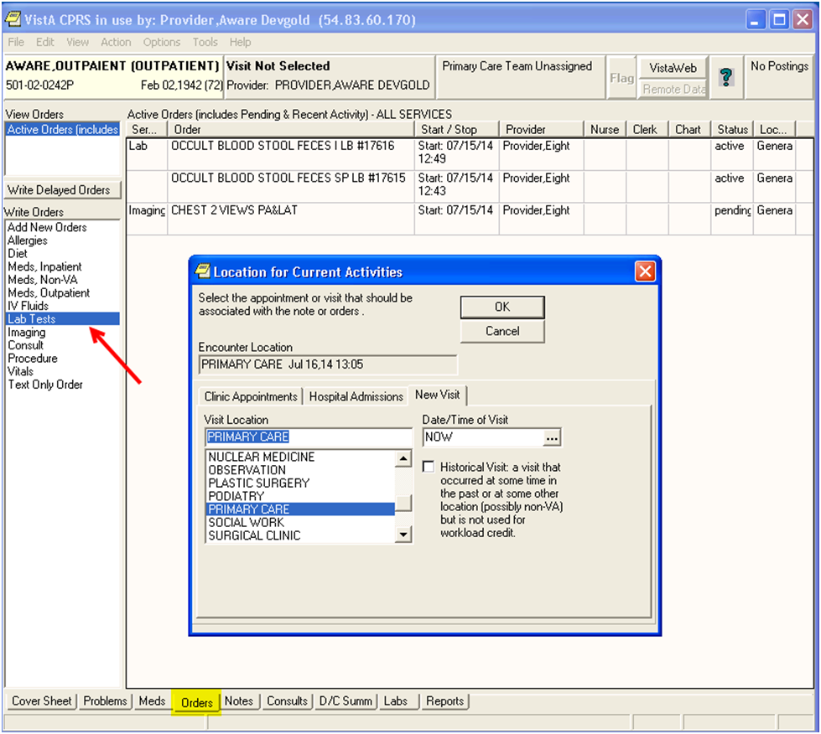

Figure - Selecting Location for Current Activities

1. Select the appropriate Lab Order you wish to test (OCCULT BLOOD or PSA). Then click the Accept Order button.

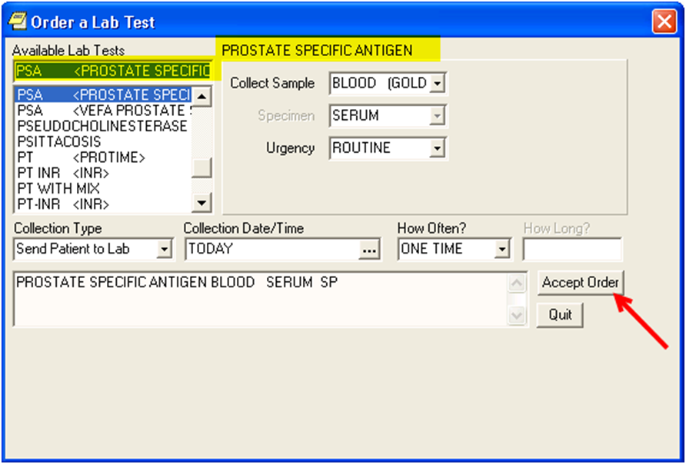

Figure - Order a Lab Test

1. Next click the Quit button.

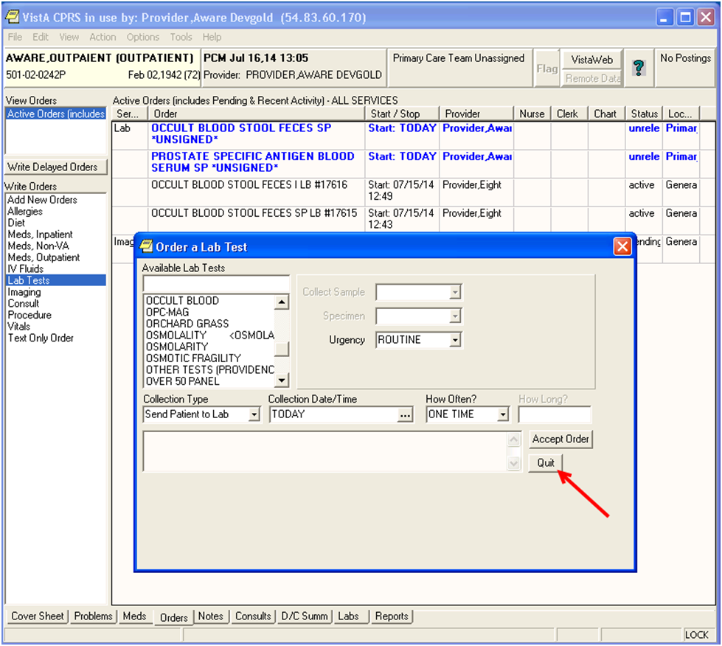

Figure - Click the Quit Button

1. Next select “File”, “Review/Sign Changes”. Enter the Electronic Signature Code and click the Sign button. The Orders Status will change to “pending”.

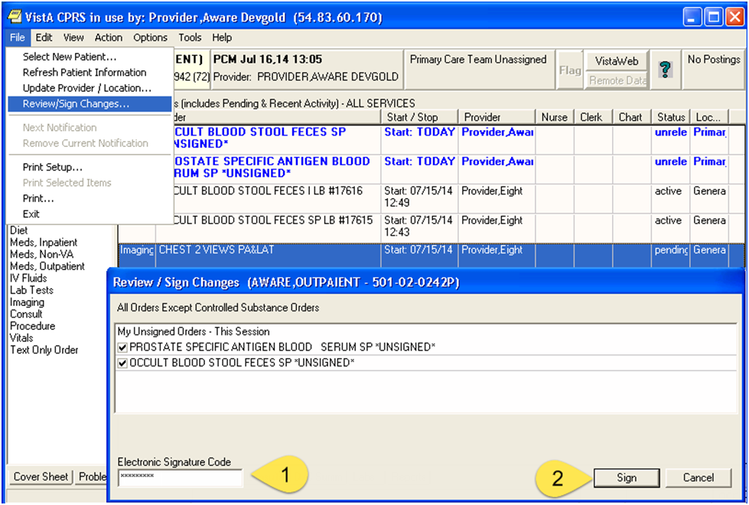

Figure - Review/Sign Changes

1. Note Lab Test number.

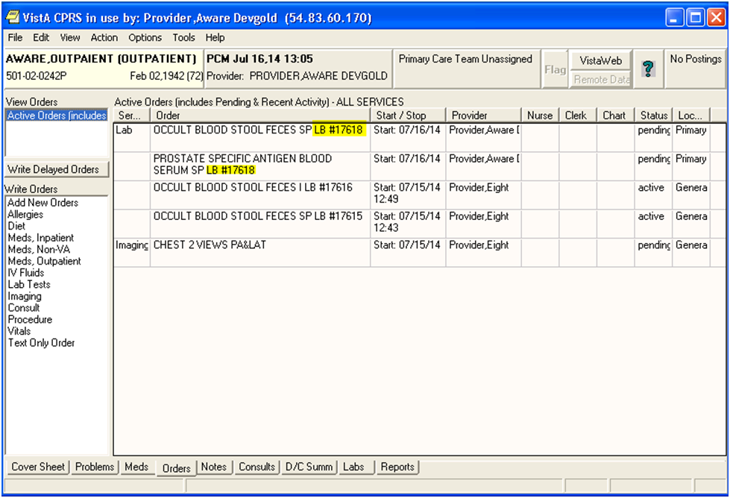

Figure - Lab Test Number

1. Log on to VistA as a Lab Technician to process the Lab Tests.

LR Laboratory DHCP Menu ... [LRMENU]

**> Locked with LRLAB

Select Laboratory DHCP Menu <TEST ACCOUNT> Option: 3 **Process data in lab menu**

EA Enter/verify data (auto instrument)

EL Enter/verify data (Load list)

EM Enter/verify/modify data (manual)

EW Enter/verify data (Work list)

MP Misc. Processing Menu ...

**Accession order then immediately enter data**

Build a load/work list

Bypass normal data entry

Download a load list to an Instrument.

Fast Bypass Data Entry/Verify

Lookup accession

Order/test status

Print a load/work list

Std/QC/Reps Manual Workload count

Unload Load/Work List

Select Process data in lab menu <TEST ACCOUNT> Option: **accession order then immediately enter data**

Select Performing Laboratory: CAMP MASTER// NY VAMC 500

Select Order number: **17618**

AWARE,OUTPAIENT 501-02-0242P Requesting location: PCM

Date/Time Ordered: 07/16/2014 13:37 By: PROVIDER,AWARE DEVGOLD

-Lab Order # 17618 Provider: PROVIDER,AWARE DEVGOLD

BLOOD SERUM

PROSTATE SPECIFIC ANTIGEN

ROUTINE Requested (SEND PATIENT) for: 07/16/2014

AWARE,OUTPAIENT 501-02-0242P Requesting location: PCM

Date/Time Ordered: 07/16/2014 13:37 By: PROVIDER,AWARE DEVGOLD

-Lab Order # 17618 Provider: PROVIDER,AWARE DEVGOLD

STOOL FECES

OCCULT BLOOD ROUTINE Requested (SEND PATIENT) for: 07/16/2014

Is this the correct order? Yes//  **YES**

Collection Date@Time: //N (JUL 16, 2014@13:45:30)

Do you have the entire order? YES

ACCESSION: JMS 14 3 <7814000003>

PROSTATE SPECIFIC ANTIGEN BLOOD SERUM

GENERAL PROCESSING INST.: This test can be processed for outside labs, as

well as in house

Sample: BLOOD

Specimen: SERUM

1 PROSTATE SPECIFIC ANTIGEN

AWARE,OUTPAIENT SSN: 501-02-0242P LOC: PCM

Pat Info: Sex: MALE Age: 72yr as of Jul 16, 2014

Provider: PROVIDER,AWARE DEVGOLD Voice pager:

Phone: Digital pager:

ACCESSION: JMS 14 3 [7814000003]

7/16 13:45d

PROSTATE SPECIFIC ANTIGEN //**18 🡨 Enter a value greater than 15.**

Select COMMENT:

AWARE,OUTPAIENT SSN: 501-02-0242P LOC: PCM

Pat Info: Sex: MALE Age: 72yr as of Jul 16, 2014

Provider: PROVIDER,AWARE DEVGOLD Voice pager:

Phone: Digital pager:

ACCESSION: JMS 14 3 [7814000003]

7/16 13:45d

PROSTATE SPECIFIC ANTIGEN 18 H* u/mL CRITICAL HIGH!!

SELECT ('E' to Edit, 'C' for Comments, 'W' Workload):

Approve for release by entering your initials: op

ACCESSION: URINE 0716 2 <2141970002>

OCCULT BLOOD STOOL FECES

Sample: STOOL

Specimen: FECES

1 OCCULT BLOOD

AWARE,OUTPAIENT SSN: 501-02-0242P LOC: PCM

Pat Info: Sex: MALE Age: 72yr as of Jul 16, 2014

Provider: PROVIDER,AWARE DEVGOLD Voice pager:

Phone: Digital pager:

ACCESSION: URINE 0716 2 [2141970002]

7/16 13:45d

OCCULT BLOOD "NEG"//POS

Select COMMENT:

AWARE,OUTPAIENT SSN: 501-02-0242P LOC: PCM

Pat Info: Sex: MALE Age: 72yr as of Jul 16, 2014

Provider: PROVIDER,AWARE DEVGOLD Voice pager:

Phone: Digital pager:

ACCESSION: URINE 0716 2 [2141970002]

7/16 13:45d

OCCULT BLOOD POS

SELECT ('E' to Edit, 'C' for Comments, 'W' Workload):

Approve for release by entering your initials: op

1. Next switch back to CPRS. Select “File”, “Refresh Patient Information”.
2. Click the “Labs” tab to see the Lab test results. When the patient record closes, the AWARE Prompt appears.

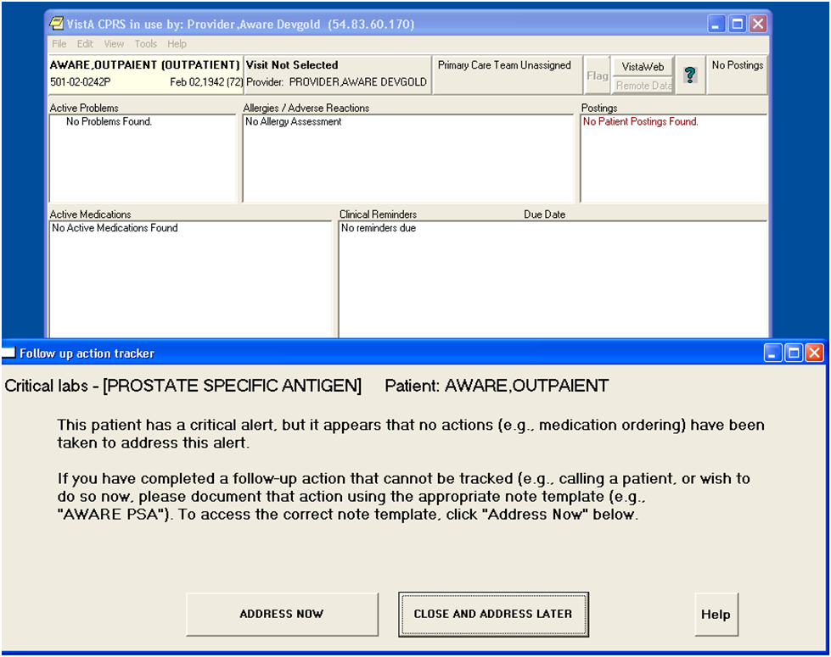

Figure - AWARE Prompt

The steps above can be repeated for any of the Lab Tests.

# 7.5 Appendix E – Examples of Site Customization with Reminder Dialogs

**NOTE: We recommend that a Clinical Informatics (i.e. a Clinical Champion M.D medical doctor), or a Clinical Application Coordinator (CAC) complete this section** as desired in the Test account for practice as these steps will be required to be done in a Production account environment before AWARE Alerts can be enabled.

Example Site Customization Steps for Reminder Dialogs with their Orderable Items/Order Dialogs/Consults/Procedures follow.

These steps may be done via other Vista options with which a Clinical Informatics (i.e. a Clinical Champion M.D medical doctor), or Clinical Application Coordinator is familiar:

Do this for the following AWARE Reminder Dialogs:

AVEFA ABNORMAL CXR reminder dialog LOCAL

AVEFA FOBT-FIT reminder dialog LOCAL

AVEFA PSA reminder dialog LOCAL

AVEFA ABNORMAL MAMMOGRAM reminder dialog LOCAL

Re-factor laboratory test and pharmacy (medication) orderable items as well as consult and procedures in your designed Order Reminder dialogs for the 4 template Reminder Dialogs delivered with the system as in explanations below:

First, for each tracked Alert type, do management of Orderable Items customized for your site for the corresponding Reminder dialog:

Run the “OI Manage Orderable Items” option below or other comparable options to define or use and existing Orderable item similarly as below:

<CPM> Select User Management Option: ORCM Order Menu Management

**OI Manage orderable items ...**

PM Enter/edit prompts

GO Enter/edit generic orders

QO Enter/edit quick orders

QU Edit personal quick orders by user

ST Enter/edit order sets

AC Enter/edit actions

MN Enter/edit order menus

AO Assign Primary Order Menu

CP Convert protocols

SR Search/replace components

LM List Primary Order Menus

DS Disable/Enable order dialogs

CS Review Quick Orders for Inactive ICD9 Codes

MR Medication Quick Order Report

CV Convert IV Inpatient QO to Infusion QO

You have PENDING ALERTS

Enter "VA to jump to VIEW ALERTS option

<CPM> Select Order Menu Management Option: **OI** Manage orderable items

Use appropriate VistA options to define Consult Request Services and use of Consults as deemed necessary in re-factoring for site customization.

Use appropriate options for defining Consult Request Service and use of Procedures such as Imaging Procedures in re-factoring for site customization.

Next, do Order Dialog building as shown similarly in examples below:

Assign ORCM MGMT menu item to IRM programmer or Clinical Coordinator

Run the “enter/edit quick order” option below to use lab/pharmacy Orderable Item, or use a Consult/Procedure as shown in examples below:

<CPM> Select User Management Option: ORCM Order Menu Management

OI Manage orderable items ...

PM Enter/edit prompts

GO Enter/edit generic orders

**QO Enter/edit quick orders**

QU Edit personal quick orders by user

ST Enter/edit order sets

AC Enter/edit actions

MN Enter/edit order menus

AO Assign Primary Order Menu

CP Convert protocols

SR Search/replace components

LM List Primary Order Menus

DS Disable/Enable order dialogs

CS Review Quick Orders for Inactive ICD9 Codes

MR Medication Quick Order Report

CV Convert IV Inpatient QO to Infusion QO

You have PENDING ALERTS

Enter "VA to jump to VIEW ALERTS option

**Example:**

<CPM> Select Order Menu Management Option: **QO Enter/edit quick orders**

Select QUICK ORDER NAME: VEFA MAMM ORDER BREAST ULTRASOUND

NAME: VEFA MAMM ORDER BREAST ULTRASOUND Replace

DISPLAY TEXT: ORDER BREAST ULTRASOUND Replace

VERIFY ORDER:

DESCRIPTION:

1>

ENTRY ACTION:

Ultrasound Procedure**: VEFA BREAST ULTRASOUND// 🡨 enter similar procedure for your site**

Procedure Modifier:

Reason for Study: Suspicious 1st and 2nd ordered Mammograms

Replace

Clinical History:

1>

Category: OUTPATIENT//

Is this patient scheduled for pre-op? NO//

Date Desired:

Mode of Transport:

Is patient on isolation procedures?

Urgency: ROUTINE//

---------------------------------------------------------------------------

Ultrasound Procedure: **VEFA BREAST ULTRASOUND 🡨-----enter replacement procedure for particular site**

Reason for Study: Suspicious 1st and 2nd ordered Mammograms

Category: OUTPATIENT

Urgency: ROUTINE

Submit request to: SBK ULTRASOUND

---------------------------------------------------------------------------

(P)lace, (E)dit, or (C)ancel this quick order? PLACE//

Auto-accept this order? NO//

Select QUICK ORDER NAME:

**Example:**

<CPM> Select Order Menu Management Option: QO Enter/edit quick orders

Select QUICK ORDER NAME: VEFA

1 VEFA CARDIO-THORACIC SURG-CSLT

2 VEFA CIPROFLOXACIN

3 VEFA COLRECTAL SURGICAL REFERRAL

4 VEFA FOBT

5 VEFA GMRCT PULMONARY

Press <RETURN> to see more, '^' to exit this list, OR

CHOOSE 1-5: 1 VEFA CARDIO-THORACIC SURG-CSLT

NAME: VEFA CARDIO-THORACIC SURG-CSLT Replace

DISPLAY TEXT: CardioThoracic Surgery Consult Replace

VERIFY ORDER:

DESCRIPTION:

1>CardioThoracic Surgery Consult

EDIT Option:

ENTRY ACTION:

Consult to Service/Specialty: VEFA CARDIOLOGY// **🡨 enter similar consult service/specialty for your site**

Consult Type:

Reason for Request:

1>Suspicious Chest X-Ray

EDIT Option:

Category: OUTPATIENT//

Urgency: STAT//

Earliest appropriate date:TODAY//

Place of Consultation: Consultant's Choice//

Attention:

Provisional Diagnosis: Suspicious Chest x-ray Replace

---------------------------------------------------------------------------

Consult to Service/Specialty: VEFA CARDIOLOGY **🡨------XXXXXX replaced consult service/specialty**

Reason for Request: Suspicious Chest X-Ray

Category: OUTPATIENT

Urgency: STAT

Earliest appropriate date:TODAY

Place of Consultation: Consultant's Choice

Provisional Diagnosis: Suspicious Chest x-ray

---------------------------------------------------------------------------

(P)lace, (E)dit, or (C)ancel this quick order? PLACE//

Auto-accept this order? NO//

**Example:**

Select QUICK ORDER NAME: VEFA CIPROFLOXACIN

NAME: VEFA CIPROFLOXACIN//

DISPLAY TEXT: Ciprofloxacin//

VERIFY ORDER:

DESCRIPTION:

1>Ciprofloxacin

EDIT Option:

ENTRY ACTION:

Medication: CIPROFLOXACIN TAB // **🡨---Enter similar pharmacy ORDERABLE item for your site**

Complex dose? NO//

Choose from (or enter another):

1 250MG $0.0361

2 500MG $0.0375

3 750MG $0.377

4 1000MG $0.075

5 1500MG $0.754

Dose: 2 500MG $0.0375

Route: ORAL (BY MOUTH)//

Schedule: BID

1 BID TWICE A DAY

2 BID AC

CHOOSE 1-2: 1 BIDTWICE A DAY

RESTRICTED

Days Supply:

Quantity (TAB):

Refills (0-11):

Pick Up: MAIL//

Priority: ROUTINE//

Comments:

1>Take as directed.

EDIT Option:

---------------------------------------------------------------------------

Medication: VEFA CIPROFLOXACIN TAB 500MG 🡨---- XXXXX replaced orderable (pharmacy) item

Instructions: 500MG ORAL (BY MOUTH) BID

Pick Up: MAIL

Priority: ROUTINE

Comments: Take as directed.

---------------------------------------------------------------------------

(P)lace, (E)dit, or (C)ancel this quick order? PLACE//

Auto-accept this order? NO//

**Example:**

Select QUICK ORDER NAME:

Select QUICK ORDER NAME: VEFA REPEAT FOBT

1 VEFA REPEAT FOBT

2 VEFA REPEAT FOBT2

CHOOSE 1-2: 1 VEFA REPEAT FOBT

NAME: VEFA REPEAT FOBT//

DISPLAY TEXT: Repeat FOBT//

VERIFY ORDER: YES//

DESCRIPTION:

1>Repeat FOBT

EDIT Option:

ENTRY ACTION:

Lab Test: 🡨 depress “enter” key

Next, for “FOBT” and “PSA”, re-enter orderable item as “site” specific lab orderable item as in examples below:

Select QUICK ORDER NAME: **FOBT**

NAME: VEFA FOBT//

DISPLAY TEXT: FOBT//

VERIFY ORDER: NO//

DESCRIPTION:

1>

ENTRY ACTION:

Lab Test: VEFA OCCULT BLOOD// 🡨----**OCCULT BLOOD** **🡨----or replace with similar specified laboratory test ORDERABLE item name for your site**

Collected By: Send patient to lab//

Collection Sample: STOOL//

Collection Date/Time: NOW//

How often: ONCE//

------------------------------------------------------------------------------

Lab Test: OCCULT BLOOD **🡨--- XXXXX replaced orderable (laboratory test) item**

Collected By: Send patient to lab

Collection Sample: STOOL

Specimen: FECES

Collection Date/Time: NOW

How often: ONCE

------------------------------------------------------------------------

(P)lace, (E)dit, or (C)ancel this quick order? PLACE//

Auto-accept this order? YES// n NO

Select QUICK ORDER NAME:

Select QUICK ORDER NAME: VEFA PSA

NAME: VEFA PSA//

DISPLAY TEXT: Reorder PSA//

VERIFY ORDER:

DESCRIPTION:

1>Reorder PSA

EDIT Option:

ENTRY ACTION:

Lab Test: VEFA PROSTATE SPECIFIC ANTIGEN// PROSTATE SPECIFIC ANTIGEN **🡨---- replace** **with similar specified laboratory test ORDERABLE item name for your site**

Collected By: Send patient to lab//

Collection Sample: BLOOD //

Collection Date/Time: NOW//

How often: NOW//

------------------------------------------------------------------------------

Lab Test: PROSTATE SPECIFIC ANTIGEN **🡨--- XXXXX replaced orderable (laboratory test) item**

Collected By: Send patient to lab

Collection Sample: BLOOD

Specimen: SERUM

Collection Date/Time: NOW

How often: NOW

------------------------------------------------------------------------

(P)lace, (E)dit, or (C)ancel this quick order? PLACE//

Auto-accept this order? NO//

Next, replace pointed VEFA placeholder Orderable Items and Order Dialogs in their associated Reminder Dialog elements similarly as in example below. These can be for laboratory test and medication (pharmacy) Orderable Items and Quick Orders (Order Dialogs) with referenced Orderable Items as well as referenced Consult Services and Procedures:

GOLD>D ^XQ1

Select OPTION NAME: PXRM DIALOG MANAGEMENT Reminder Dialog Management

DP Dialog Parameters ...

DI Reminder Dialogs

DR Dialog Reports ...

IA Inactive Codes Mail Message

<CPM> Select Reminder Dialog Management Option: DI Reminder Dialogs

Dialog List Feb 03, 2014@11:32:40 Page: 1 of 11

REMINDER VIEW (ALL REMINDERS BY NAME)

Item Reminder Name Linked Dialog Name & Dialog Status

1 ARD 00 ANTICOAGULATION AFIB

2 BL PCLC NEEDED

3 BL PHQ9 NEEDED UPDATE PHQ2 INFO TEXT Disabled

4 BL SUICIDE RISK NEEDED

5 CHF OUTPATIENT EDUCATION

6 CRD 00 ANTICOAG FOR AFIB

7 CRD ANTICOAG FOR AFIB

8 DIABETES - RETINAL EXAM PH DIABETIC RETINAL EXAM

9 DIABETES CREATININE

10 DIABETES HBA1C

11 DIABETES URINALYSIS

12 EVALUATION OF + DEPRESSION SCREEN EVALUATION OF + DEPRESSION Disabled

13 EVALUATION OF + PTSD SCREEN EVALUATION OF + PTSD SCREEN Disabled

14 HEP C - DZ & TRANSMISSION EDUCATIO

15 HEP C - EVALUATION FOR TREATMENT HEP C - EVALUATION FOR TREA

16 HEP C RISK FACTOR SCREENING HEP C RISK FACTOR SCREENING

+ Enter ?? for more actions >>>

AR All reminders LR Linked Reminders QU Quit

CV Change View RN Name/Print Name

Select Item: Next Screen// CV Change View

Select one of the following:

D Reminder Dialogs

E Dialog Elements

F Forced Values

G Dialog Groups

P Additional Prompts

R Reminders

RG Result Group (Mental Health)

RE Result Element (Mental Health)

TYPE OF VIEW: R// D Reminder Dialogs

Dialog List Feb 03, 2014@11:32:57 Page: 1 of 4

DIALOG VIEW (REMINDER DIALOGS - SOURCE REMINDER NAME)

Item Reminder Dialog Name Source Reminder Status

1 ARD 227H ANTICOAGULATION FOR AFIB ARD 00 ANTICOAGULATION AF

2 AVEFA ABNORMAL CXR *NONE*

3 AVEFA ABNORMAL MAMMOGRAM *NONE*

4 AVEFA FOBT-FIT *NONE*

5 AVEFA PSA *NONE*

6 CRD ANTICOAG AFIB/FLUTTER ARD 00 ANTICOAGULATION AF

7 EMPLOYEE PPD - >13MONTHS *NONE*

8 EVALUATION OF + DEPRESSION SCREEN EVALUATION OF + DEPRESSIO Disabled

9 EVALUATION OF + PTSD SCREEN EVALUATION OF + PTSD SCRE Disabled

10 HEP C - EVALUATION FOR TREATMENT HEP C - EVALUATION FOR TR Linked

11 HEP C RISK FACTOR SCREENING HEP C RISK FACTOR SCREENI Linked

12 HEP C TESTING FOR AT RISK PT HEP C TESTING FOR AT RISK Linked

13 HIV RPR *NONE* Disabled

14 HTN AND BP>140 OR >90 HTN AND BP>140 OR >90 Linked

15 HTN DIAGNOSIS HTN DIAGNOSIS Linked

16 HTN ELEVATED BP>140/90 HTN ASSESSMENT BP >140/90 Disabled

+ + Next Screen - Prev Screen ?? More Actions >>>

AD Add Reminder Dialog PT List/Print All QU Quit

CV Change View RN Name/Print Name

Select Item: Next Screen// 5

Dialog Edit List Feb 03, 2014@11:33:19 Page: 1 of 3

REMINDER DIALOG NAME: AVEFA PSA

Item Seq. Dialog Summary

1 1 Group: AVEFA PSA ORDERS GROUP

2 1..5 Element: AVEFA PSA REPEAT PSA

3 1.1 Element: AVEFA PSA ORDER UROLOGY CONSULT (Disabled)

4 1.2 Element: AVEFA PSA ORDER URINE CULTURE

5 1.4 Element: AVEFA PSA ORDER URINALYSIS

6 1.5 Element: AVEFA PSA ORDER CIPRO

7 1.6 Element: AVEFA PSA ORDER BACTRIM

8 1.7 Element: AVEFA PSA RADIATION ONCOLOGY CSLT

+ + Next Screen - Prev Screen ?? More Actions >>>

ADD Add Element/Group DS Dialog Summary INQ Inquiry/Print

CO Copy Dialog DO Dialog Overview QU Quit

DD Detailed Display DT Dialog Text

DP Progress Note Text ED Edit/Delete Dialog

Select Item: Next Screen// 4

Select one of the following:

E Edit

C Copy and Replace current element

D Delete element from this dialog

Select Dialog Element Action: E// EDIT Edit

Dialog Element Type: E// Element

Current dialog element/group name: AVEFA PSA ORDER URINE CULTURE

Used by: AVEFA PSA ORDERS GROUP (Dialog Group)

NAME: AVEFA PSA ORDER URINE CULTURE Replace ... With AW500 PSA ORDER URINE CULE

Replace

AW500 PSA ORDER URINE CULTURE

DISABLE:

CLASS: LOCAL//

SPONSOR:

REVIEW DATE:

RESOLUTION TYPE: ORDERED//

ORDERABLE ITEM: VEFA CULTURE & SUSCEPTIBILITY// **🡨-- Replace any Orderable Item “required” value here for use at this site, i.e. URINE CULTURE & SUSCEPTIBILITY**

Finding item: Q VEFA Urine Culture and Susceptibility **🡨----Replace any Quick Order (Order Dialog) with Q.---------(value) such as Q. Urine Culture and Susceptibility for use at this site**

FINDING ITEM: Urine Culture and Susceptibility

//

Additional findings:

HF AW500 PSA ORDER URINE CULTURE Finding # 1

Select ADDITIONAL FINDING:

DIALOG/PROGRESS NOTE TEXT:

Order Urine Culture

Edit? NO//

ALTERNATE PROGRESS NOTE TEXT:

No existing text

Edit? NO//

EXCLUDE FROM PROGRESS NOTE:

SUPPRESS CHECKBOX:

Select SEQUENCE:

REMINDER TERM:

Input your edit comments.

Edit? NO//

Dialog Edit List Feb 03, 2014@11:35:29 Page: 1 of 3

REMINDER DIALOG NAME: AVEFA PSA

Item Seq. Dialog Summary

1 1 Group: AVEFA PSA ORDERS GROUP

2 1..5 Element: AVEFA PSA REPEAT PSA

3 1.1 Element: AVEFA PSA ORDER UROLOGY CONSULT (Disabled)

4 1.2 Element: AW500 PSA ORDER URINE CULTURE

5 1.4 Element: AVEFA PSA ORDER URINALYSIS

6 1.5 Element: AVEFA PSA ORDER CIPRO

7 1.6 Element: AVEFA PSA ORDER BACTRIM

8 1.7 Element: AVEFA PSA RADIATION ONCOLOGY CSLT

+ + Next Screen - Prev Screen ?? More Actions >>>

ADD Add Element/Group DS Dialog Summary INQ Inquiry/Print

CO Copy Dialog DO Dialog Overview QU Quit

DD Detailed Display DT Dialog Text

DP Progress Note Text ED Edit/Delete Dialog

Select Item: Next Screen//Q